Texas Commission on Environmental Quality
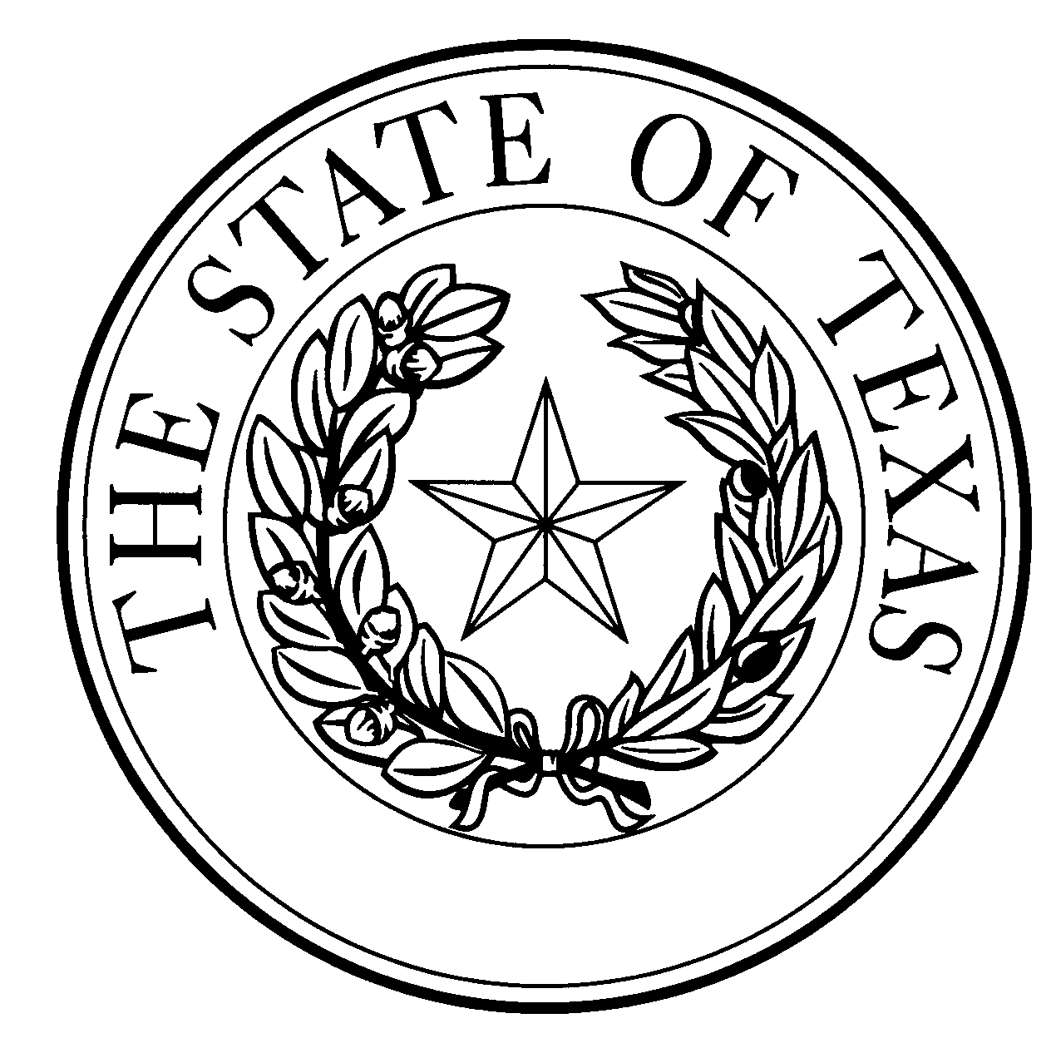
  - Notice of Concentrated Animal Feeding Operation Application
General Permit Authorization No. TXG921192
Application. Prestage Farms of Oklahoma, LLC, PO Box 509, Texhoma, Oklahoma 73949 has applied to the Texas Commission on Environmental Quality (TCEQ) under General Permit No. TXG920000 for a non-substantial change to the terms of the nutrient management plan (NMP) previously submitted to the TCEQ. The Applicant is proposing to add a covered digester for retention control structure (RCS) #13. Other changes include changing the facility name from Vall Swine Feedlot to Farms 12-14. The facility maps and calculations have been revised as a result of the addition of the digester. The authorized maximum capacity of 23,200 head of swine and the currently authorized total land application area of 500 acres will remain the same. The notice of change application and the updated NMP were received by TCEQ on September 7, 2022.
No discharge of pollutants into the waters in the state is authorized by this general permit except under chronic or catastrophic rainfall conditions or events. All waste and wastewater will be beneficially used on agricultural land.
The facility is located at 6990 State Highway 15, Stratford, Sherman County, Texas. The facility is located in the drainage area of an unclassified tributary in Segment No. 0100 of the Canadian River Basin. The following link to an electronic map of the site or facility’s general location is provided as a public courtesy and is not part of the application or notice. https://tceq.maps.arcgis.com/apps/webappviewer/index.html?id=db5bac44afbc468bbddd360f8168250f&marker=-101.84166%2C36.328333&level=12. For the exact location, refer to the application.
The Executive Director of the TCEQ has approved the proposed non-substantial change to the terms of the NMP. The revised terms of the NMP have been included in the permit record and it is available at the TCEQ’s Central Records, 12100 Park 35 Circle Austin, Texas 78753.
Information. For additional information about this application, contact Robert Chavez at (512) 239-0442. Si desea información en Español, puede llamar al 1-800-687-4040. General information regarding the TCEQ can be found at our web site at www.tceq.texas.gov/.

Issued: November 15, 2022

