Texas Commission on Environmental Quality
  - Notice of Concentrated Animal Feeding Operation Application
General Permit Authorization No. TXG921504
Application. Prestage Farms of Oklahoma, LLC, P.O Box 509, Texhoma, Oklahoma 73949 has applied to the Texas Commission on Environmental Quality (TCEQ) under General Permit No. TXG920000 for a non-substantial change to the terms of the nutrient management plan (NMP) previously submitted to the TCEQ. The Applicant is requesting that the TCEQ should revise the issued certificate to show the swine population that are confined at this facility to be consistent with the design calculations showing the number of animals weighing over 55 lbs and those weighing less than 55 lbs. Below is the screenshot of the manure production characteristics showing the breakdown of the animals that are onsite. The table shows 4,400 nursery pigs weighing less than 55 lbs, and the remainder of 10,125 pigs weigh over 55 lbs. The previous registration and authorization that were reviewed include WQ0003002000 and TXG920327.
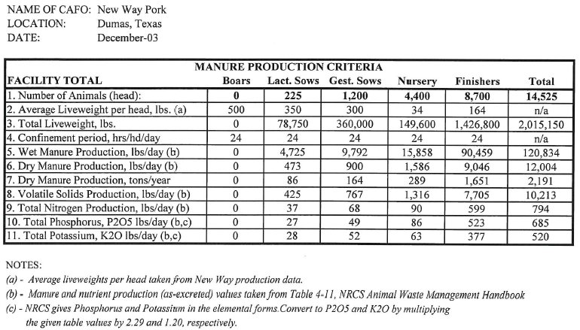
The notice of change application and the updated NMP were received by TCEQ on February 22, 2022.
No discharge of pollutants into the waters in the state is authorized by this general permit except under chronic or catastrophic rainfall conditions or events. All waste and wastewater will be beneficially used on agricultural land.
The facility is located at 6100 Farm-to-Market Road 722, Dumas, Moore County, Texas. The facility is located in the drainage area of the Lake Meredith in Segment No. 0102 of the Canadian River Basin. The following link to an electronic map of the site or facility’s general location is provided as a public courtesy and is not part of the application or notice. https://tceq.maps.arcgis.com/apps/webappviewer/index.html?id=db5bac44afbc468bbddd360f8168250f&marker=-102.03222%2C35.787777&level=12. For the exact location, refer to the application.
The Executive Director of the TCEQ has approved the proposed non-substantial change to the terms of the NMP. The revised terms of the NMP have been included in the permit record and it is available at the TCEQ’s Central Records, 12100 Park 35 Circle Austin, Texas 78753.
Information. For additional information about this application, contact Joy Alabi at (512) 239-1318. Si desea información en Español, puede llamar al 1-800-687-4040. General information regarding the TCEQ can be found at our web site at www.tceq.texas.gov/.

Issued: April 06, 2022

