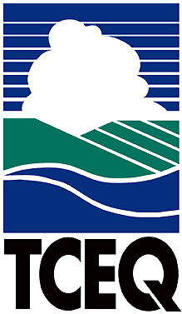
National Comments

Executive Review Summary

TCEQ Proposed Comments On:
Request for Public Comment on Revised Definition of Waters of the United States. February 14, 2019 Federal Register (84 Fed. Reg. 4154).

Overview of Proposal:
On February 14, 2019, the U. S. Environmental Protection Agency and the Department of the Army (the Agencies) published notice of proposed revisions to the rule defining the scope of waters federally regulated under the Clean Water Act (CWA). The proposed definition would establish national consistency and rebalance the relationship between the federal government and states in managing land and water resources. In addition to general public comment, the Agencies are soliciting feedback on questions regarding specific rule topics.

The proposed revisions are the second step in a two-step process to repeal and replace the final 2015 Clean Water Rule (CWR), published in the June 29, 2015 Federal Register. The 2015 CWR is the subject of extensive litigation, which has caused a regulatory patchwork and resulted in considerable uncertainty. The 2015 CWR is not applicable in Texas, due to an injunction issued by the U.S. Southern District of Texas; however, it is in effect in 22 other states. To develop the proposed replacement rule, the Agencies considered the U.S. Supreme Court’s plurality opinion written by Justice Scalia in Rapanos v. United States. In this opinion, waters protected by the CWA are those that are “relatively permanent, standing or continuously flowing bodies of water” connected to traditional navigable rivers or streams, as well as wetlands with a “a continuous surface connection to such water bodies.” Accordingly, the Agencies proposal excludes features that are ephemeral (including ephemeral streams), wetlands that do not abut or have a direct hydrological surface connection to a jurisdictional water, certain ditches, and other previously-excluded features.

Summary of Comments:
Comments support the overall efforts by the Agencies to clarify the rule and “recognize, preserve, and protect the primary responsibilities and rights of the States to prevent, reduce, and eliminate pollution” authorized by Section 101(b) of the CWA. Specific suggestions to improve efficiency of implementation are provided in response to the Agencies’ solicitation for feedback on selected topics. The TCEQ has also provided comments and suggestions on pertinent topics that may impact state water quality management programs.

Lead Office: Allison Woodall, Office of Water

Internal Coordination:
Jill Csekitz, Water Quality Planning Division, Office of Water
Gregg Easley, Water Quality Division, Office of Water
Michael Parr, Office of Legal Services, Environmental Law Division, 239-0611

Deputy Director Approval: L’Oreal W. Stepney, P.E., Office of Water

Deadline: April 15, 2019

