FTPS User’s Quick Guide for Solicitations

How to Create an Account
- Enter https://ftps.tceq.texas.gov.ut_php into your web browser.
Note: it is important to use the same computer when creating an account and when accessing emails from the FTPS system.
- Click on the “Sign up a new account” button.
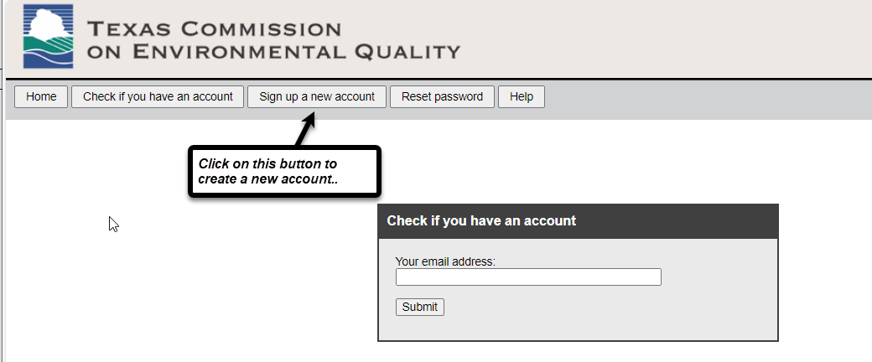
- Enter a name (company name, for example) and an email address. These two fields are required to be completed. Click the Submit button when done.
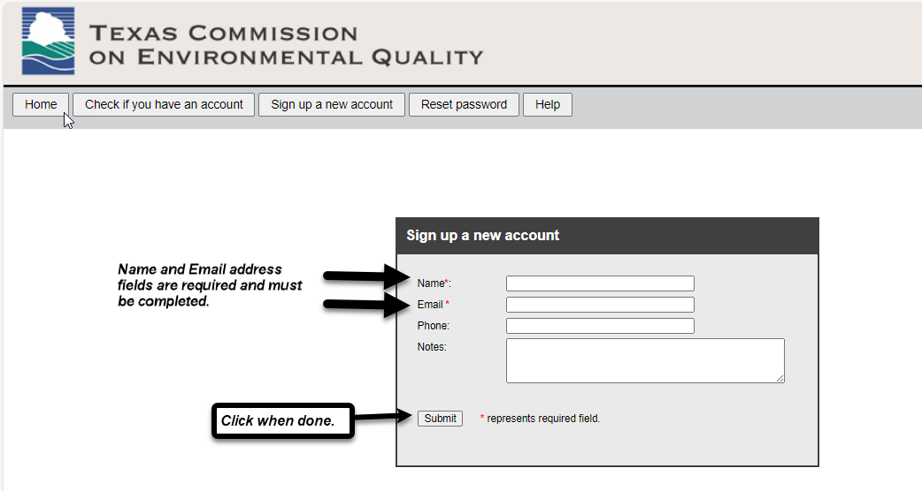
- A confirmation box will appear with additional information. Click the OK button.
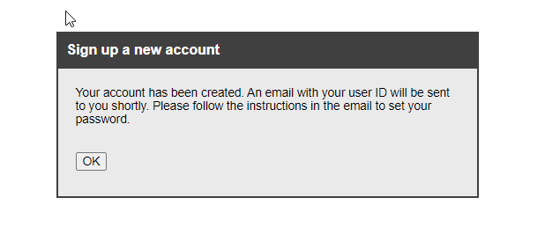
- Check for an email from ftp_account@tceq.texas.gov. To set up your password for your account, click on the link in the email. This will take you back to the FTPS site.
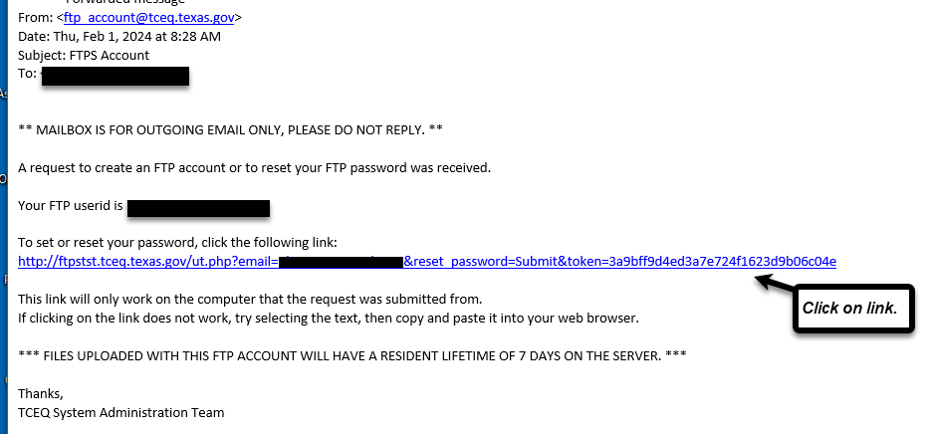

- Set your password, then click the “Reset Password” button.
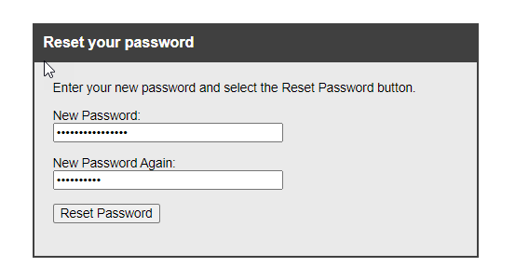
- A box appears, confirming that your password has been reset. Click “OK”.
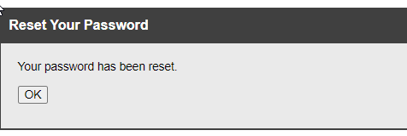

How to Use FTPS to Upload Documents
- Enter https://ftps.tceq.texas.gov.ut_php into your web browser.
- Enter your Username and Password. Click “Login”.
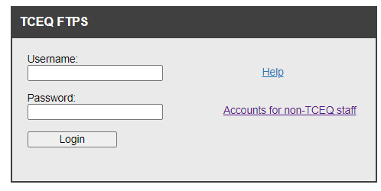
- Click on the “Upload Files” button at the bottom of the screen.
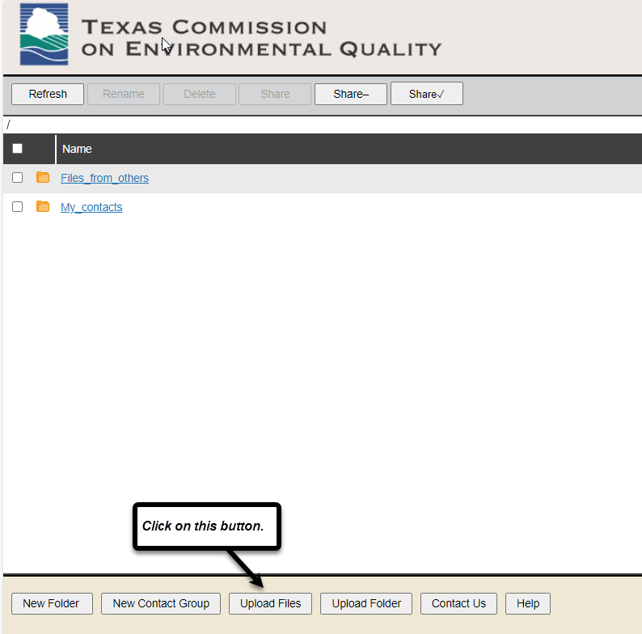
- From your computer, find and click on the file or files you want to upload. You can upload multiple files at one time.
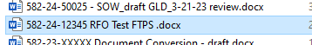
- The uploaded file(s) will now appear in the list. Place a check in the box beside the file or files to be shared. Once the files are selected, click the “Share” button.
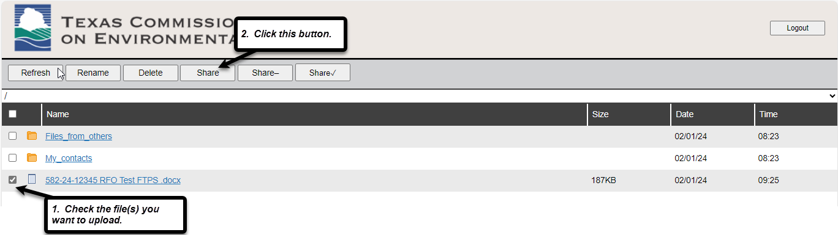
- In the pop-up “Share Files” box, enter esbd-response@tceq.texas.gov in the email address box and click the “Add” button. Confirm the correct email address was entered, and then click the “OK” button.
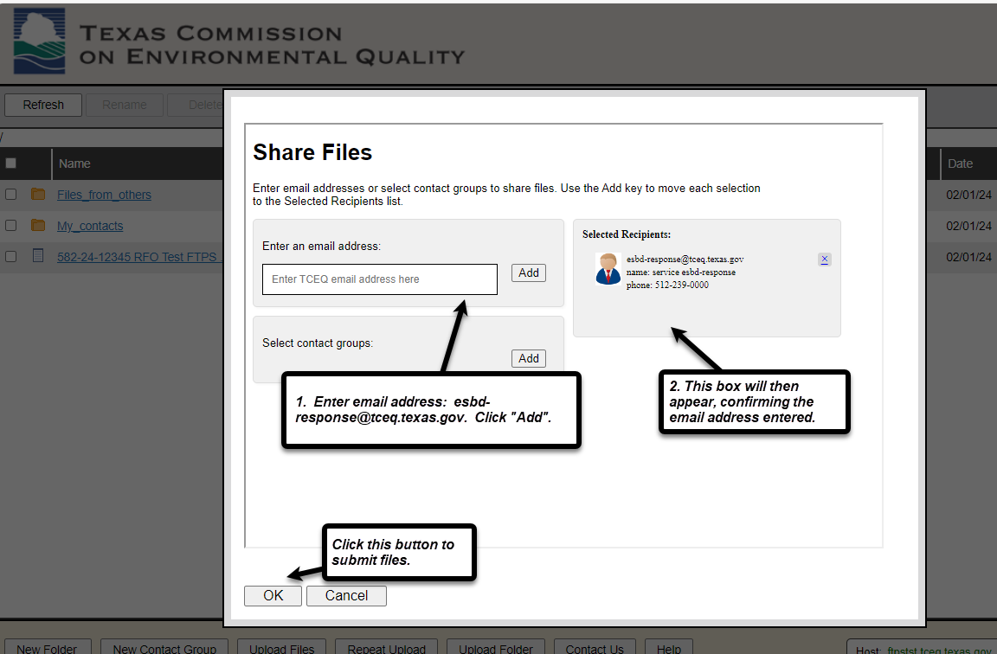
- Another confirmation screen appears, displaying the file or files that have been uploaded and the email address. Click the “OK” button.
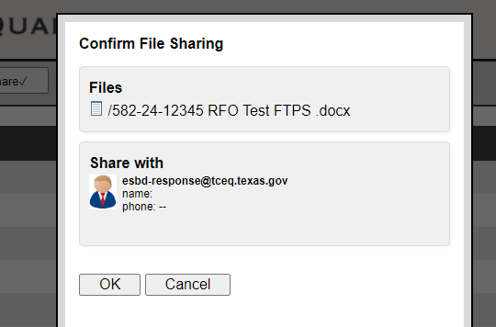
- IMPORTANT: The “Notify Recipients” box appears with pre-filled text. Insert the solicitation number and name in front of the pre-filled text. The text in the red box, below, is an example. Click the “OK” button.
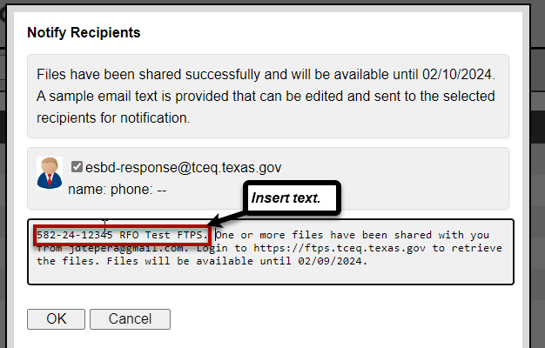
- “A confirmation that the email was sent appears. Click the “OK” button.
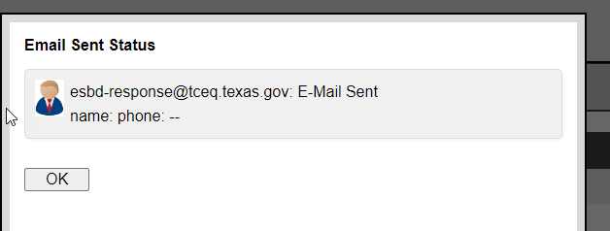
- You will be returned to the Home page. Click the “Logout” button in the top right corner.
-End-

