Template for an
Emergency Action Plan
for an Intermediate or Small Dam

Revised 2019

[Name] Dam

[TX#####]

Emergency Action Plan

[Date]
Prepared for
[Name]
Prepared by
[Name]

Emergency Action Plan
[Name] Dam, [TX#####]
[Owner]

Contents
Notification Flowchart (Watch Condition) [--]
Notification Flowchart (Possible, Imminent, or Dam Failure Condition) [--]
EAP Distribution List [--]
Log Sheet of Changes [--]
Approval and Implementation [--]
Emergency Action Plan [--]
1. Purpose [--]
2. Dam Description [--]
2.1. General [--]
2.2. Reservoir Operations [--]
3. Responsibilities [--]
3.1. Dam Owner’s Responsibilities [--]
3.2. Responsibilities for Notification [--]
3.3. Emergency Operations Center [--]
3.4. Responsibilities for Evacuation [--]
3.5. Responsibilities for Duration, Security, Termination, and Follow-up [--]
4. Emergency Detection, Evaluation, and Classification [--]
4.1. Emergency Detection [--]
4.2. Emergency Evaluation and Classification [--]
4.3. Previously Known Problems [--]
5. Preparedness [--]
6. Supplies and Resources [--]
7. Inundation Area [--]
8. Implementation [--]
8.1. Development [--]
8.2. Updating [--]
8.3. Testing [--]
8.4. Training [--]
Tab 1. Vicinity Map [--]
Tab 2. Inundation Map [--]
Tab 3. Dam Description [--]
Tab 4. Sample Public Announcements [--]
Tab 5. Directory of Personnel with Dam Safety Expertise [--]
Tab 6. Supplies and Resources [--]
Tab 7. Annual EAP Evaluation Checklist [--]
Tab 8. Plan Review and Update [--]
Tab 9. Training Record [--]

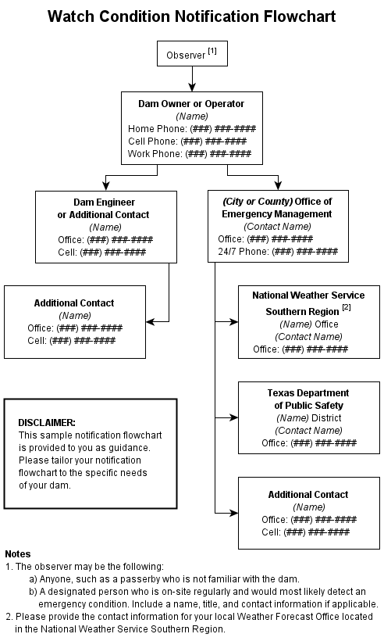

[Name] Dam, [TX#####]

EAP Distribution List
A copy of the EAP has been provided to the following individuals.

Authority | Name, Title, Phone | Address

Owner(s) and Representatives
Office of Emergency Management  [AAA County or AAA City] | Emergency Management Coordinator  [Name of Contact]  Phone ###-###-####
Texas Department of Transportation  District [###] | [Name of Contact]  Phone ###-###-####
Texas Commission on Environmental Quality | (512) 239-0326 (daytime)  (888) 777-3186 (after hours) | Dam Safety Section, MC 177  P.O. Box 13087  Austin, TX 78711
Engineer  [Company Name] | [Name of Contact]  Phone ###-###-####

[Name] Dam, [TX#####]

Log Sheet Of Changes
The following changes have been made to the EAP and revisions have been provided to the individuals shown on the EAP Distribution List.

Date | Change Made | Signature

Approval And Implementation

Emergency Action Plan

[Name] Dam, [TX#####]

This Emergency Action Plan is hereby approved. This plan is effective immediately and supersedes all previous editions.

[Name and Title] of Appropriate Manager for Owner Date
I have received a copy of this Emergency Action Plan and concur with the notification procedures.

[Name and Title] of Emergency Management Coordinator Date

Emergency Action Plan

[Name] Dam, [TX#####]

1. Purpose
The purpose of this Emergency Action Plan (EAP) is to identify emergency situations that could threaten [Name] Dam and to plan for an expedited, effective response to prevent failure of the dam and warn downstream residents of impending danger. This plan defines the notification procedures to be followed in the event of a potentially hazardous situation. The procedures are intended to protect lives and prevent property damage from an uncontrolled release of water from the reservoir.

2. Dam Description

2.1. General
A vicinity map showing the location of the dam can be found in Tab 1. An inundation map illustrating the areas subject to flooding as a result of a dam failure can be found in Tab 2.
[Describe the dam in this section and/or reference the Dam Description in Tab 3].

2.2. Reservoir Operations
[The purpose of this section is to identify features and controls on the dam that would be used to release water and to explain how they would be implemented during an emergency. If the dam does not have any controls, the statement “Releases from the reservoir are uncontrolled” will suffice.]

3. Responsibilities

3.1. Dam Owner’s Responsibilities
The owner, [Name], is responsible for all dam operation and maintenance. The EAP will not designate a specific person for each responsibility, but instead will designate the person’s title or job description.
The [title] is the first line of dam observers and is the person responsible for initiating implementation of the EAP. The [title] is responsible for conducting routine dam maintenance, such as annual brush control, conducting dam integrity inspections, and notifying [title] of any potential emergency situations. The [title] is responsible for contacting emergency personnel should a dam failure be imminent.
The [title] is also responsible for updating the EAP. An annual EAP review should be conducted to ensure that contact names and numbers are current on the Notification Flowcharts.
The [title] is also responsible for directing specific, incident appropriate actions during an emergency, such as opening or closing water intakes and remedial construction activities such as dirt moving, etc. Specific scenarios are not listed in this EAP.

3.2. Responsibilities for Notification
The [title] is responsible for inspecting the dam in a potential emergency such as the potential threat of high waters or a tornado. The [title] will contact the [AAA County Sheriff or AAA City Police] and emergency management coordinator.
If warranted, the [title] will notify the TCEQ Dam Safety Section. The [AAA County Sheriff or AAA City Police] will notify downstream residents. The [AAA County or AAA City] emergency management coordinator will implement the Notification Flowchart for regional and state emergency management contacts and contact the proper media outlets. Sample public announcements appear in Tab 4.

3.3. Emergency Operations Center
In the event of a “possible dam failure” or more serious condition, the [title of emergency management coordinator] will activate the Emergency Operations Center to serve as the main distribution center for warning and evacuation activities. The Emergency Operations Center will be established at the [location of office]. The [title of emergency management coordinator] will be responsible for initiating actions from this location.
[For small-size dams or intermediate-size dams that do not require local agencies to activate an Emergency Operations Center; omit the paragraph above. Instead, use this section to designate a safe and accessible area near the dam where the owner and emergency officials can gather to monitor the emergency event and direct emergency actions.]

3.4. Responsibilities for Evacuation
The [AAA County Sheriff or AAA City Police] is responsible for initiating evacuations.

3.5. Responsibilities for Duration, Security, Termination, and Follow-up
The [title] is responsible for monitoring of emergency situations at the dam and keeping authorities informed, based on the Notification Flowcharts.
The [title] and the [title of emergency management coordinator] are responsible for declaring that an emergency at the dam is terminated. Applicable authorities will be notified based on the Notification Flowcharts.
The [title] will ensure that a follow-up evaluation is completed by all participants after the emergency. The results of the evaluation should be documented in a written report and filed with the EAP.

4. Emergency Detection, Evaluation, and Classification

4.1. Emergency Detection

A. Situations
Many dam conditions can lead to emergency situations, not all of which will necessitate the implementation of the EAP. However, if any of them occur, the appropriate actions will be taken.
Severe Storms/Inclement Weather: Although generally not in themselves a threat to the dam, severe storms and other inclement weather conditions can contribute to an existing problem and hinder any remediation efforts. Severe storms also cause the uncontrolled release of floodwater, and increase flow in already rain-swollen areas.
Tornadoes: Tornadoes do occur in the area, with the potential for structural damage to the dam, possibly resulting in its failure. If a tornado has struck in the area, an inspection of the dam for any signs of damage will be appropriate.
Earthquakes: [Dam Name] is located in a seismic zone with low activity. An earthquake is, however, a possibility, and appropriate post-earthquake inspections should be performed.
Sabotage: A threat to damage the dam has been made. Appropriate actions will be taken to protect the dam.

B. Signs of Failure
The [title] is responsible for conducting routine inspections and identifying conditions that could indicate the onset of problems leading to a dam failure. The early identification of potentially dangerous conditions can allow time for the implementation of the EAP. It is important to understand how distress can develop into failure. With appropriate action, distress need not lead to a catastrophic failure of the dam. The following sections describe some of the different types of failure which could lead to a dam failure.
Seepage Failure: Although all earthen embankments allow some minor seepage through the dam or the foundation, excessive, uncontrolled seepage can result in piping (or the movement of embankment material in the seepage flow) and lead to failure. Piping can occur for years at a slow rate. If the piping has progressed to a dangerous level, it will be evident by increased flow or the discharge of muddy water (or both). At that stage, immediate action to stop the piping is needed. Fully developed piping is difficult to control and is very likely to result in failure. A whirlpool in the reservoir is a sign of uncontrollable piping and necessitates immediate emergency action.
Embankment or Foundation Sliding: Sliding is usually first apparent when cracks or bulges in the embankment appear. Slides with progressive movement can cause failure of the embankment.
Structural Failure: The structural failure or collapse of any portion of the principal spillway or spillway gates could result in loss of the reservoir. A structural failure of a portion of the spillway could cause piping and possibly embankment failure.
Overtopping Failure: Overtopping of the embankment results in erosion of the dam crest. Once erosion begins, it is very difficult to stop.

4.2. Emergency Evaluation and Classification
This section lists the conditions and actions which may be used to classify the level of emergency response, as a guide for the [Owner].
Watch Condition: A problem has been detected at the dam which requires constant monitoring or immediate action to repair or correct. At this time, the distress condition is manageable by dam personnel.
The [Owner] will be responsible for monitoring and repair as soon as possible and implementing the appropriate Notification Flowchart. The following is a list of conditions which constitute “watch” conditions:
- cloudy or dirty seepage or seepage with an increase in flow, boils, piping, or bogs
- seepage around conduits
- large sinkholes with corresponding seepage anywhere on the embankment or downstream from the toe
- any slide that degrades the crest of the embankment or that is progressively increasing in size
- cracking or movement of any concrete structure
- the engagement of the emergency spillway
Possible Dam Failure Condition: A “watch” condition that is progressively getting worse. A situation is developing that could cause the dam to fail. Efforts to correct the situation will continue. There is no immediate danger; however, if conditions continue to deteriorate, the dam could fail.
The [Owner] will be responsible for initiating immediate repairs, including lowering the reservoir if appropriate and implementing the appropriate Notification Flowchart. The following is a list of conditions which constitute “possible dam failure” conditions:
- large boils, increasing in size and flow rate, especially if there is flowing muddy water
- significantly increasing seepage, especially flowing muddy water
- slides involving a large mass of material that impairs the crest of the dam and is continuing to move
- sinkholes with seepage flowing muddy water
- large cracks, movement or failure of a portion of any major concrete structure that forms an integral part of the dam
- an increase in the reservoir level to near the top of the dam
- overtopping of a dam that is not designed for overtopping
Imminent Dam Failure/Dam Failure Condition: The [Owner] has determined that a dam failure is occurring or has already occurred and will result in flooding that threatens life and property. No time remains to implement measures to prevent failure. Evacuation has begun and will continue until the situation is stabilized.
The [Owner] is responsible for implementing the appropriate Notification Flowchart. The following is a list of conditions which constitute “imminent dam failure” or “dam failure” conditions:
- rapidly increasing boils or the presence of new, significantly flowing boils, particularly muddy ones near previously identified ones
- rapidly increasing seepage, especially flowing muddy water
- slides involving a large mass of material or which have degraded the crest of the embankment to a level that approaches the water surface level, or if significant seepage is observed through the slide area
- settlement that is predicted to degrade to the reservoir level
- cracks that extend to the reservoir level
- significant movement or failure of any structure that forms an integral part of the dam
- overtopping of an earthen dam
- uncontrollable release of the reservoir

4.3. Previously Known Problems
[Identify any known problems with the dam such as those outlined in previous dam safety inspections.]

5. Preparedness
Preparedness actions are to be taken both before and following the development of emergency conditions and should identify ways of preparing for an emergency, increasing response readiness in a uniform and coordinated manner, and helping to reduce the effects of a dam failure. The following are some steps that could prevent or delay failure after an emergency is first discovered.
Surveillance: [title] will monitor the dam during emergency situations such as a severe storm event.
Response during weekends and holidays: [title] will be available for emergency response during weekends and holidays and can be present at the dam site within [# minutes] of detection of an emergency condition.
Response during periods of darkness and adverse weather: [title] will arrange for access to generators and lights to adequately monitor the situation. [title] will be able to access the site during adverse weather conditions by [method of access - i.e. foot, utility vehicle, etc.].
Access to the site: Alternate access routes should be planned in the event of an emergency at the dam. [Example: The road across the dam is a gravel roadway with grass edges which should allow discharge across the road rendering this route inaccessible. The north and east alternate routes should be used instead under such conditions. All-weather access to the downstream toe of the dam will also be unavailable. For developing situations near the downstream toe of the dam, gravel may need to be brought in to stabilize a road in that area.]
The following actions should only be undertaken under the direction of a professional engineer or contractor. In all cases, the appropriate Notification Flowchart must be implemented and the personnel of the TCEQ Dam Safety Section must be notified.
Local professionals with dam experience should be contacted as needed. A Directory of Personnel with Dam Safety Expertise can be found in Tab 5.
Consider the following preparedness actions if the dam’s integrity is threatened by:
Overtopping by flood waters:
- Give erosion-resistant protection to the downstream slope by placing plastic sheets or other materials over eroding areas.
- Divert floodwaters around the reservoir basin, if possible.
A slide on the upstream or downstream slope of the embankment:
- Lower the water level in the reservoir at a rate, and to an elevation, considered safe given the slide condition. If the outlet is damaged or blocked, pumping or siphoning may be required.
- Stabilize any slide on the downstream slope by weighting the toe area below the slide with additional soil, rock, or gravel.
Erosional seepage or leakage (piping) through the embankment, foundation, or abutments
- Plug the flow with whatever material is available (hay bales, bentonite, or plastic sheeting, if the entrance to the leak is in the reservoir).
- Lower the water level in the reservoir until the flow decreases to a non-erosive velocity or until it stops.
- Place an inverted filter (a protective sand and gravel filter) over the exit area to hold materials in place.
- Continue lowering the water level until a safe elevation is reached; continue operating at a reduced level until repairs are made.
A failure of an appurtenant structure such as an inlet or outlet of the spillway
- Implement temporary measures to protect the damaged structure, such as closing the inlet or putting in place temporary protection for a damaged spillway.
- Employ experienced, professional divers, if necessary, to assess the problem and possibly implement repair.
- Lower the water level in the reservoir to a safe elevation. If the inlet is inoperable, pumping or siphoning may be required.
A mass movement of the dam on its foundation (spreading or mass sliding failure)
- Immediately lower the water level until excessive movement stops.
- Continue lowering the water level until a safe level is reached; continue operation at a reduced level until repairs are made.
Auxiliary spillway erosion threatening reservoir evacuation
- Provide temporary protection at the point of erosion by putting in place sandbags, riprap materials, or plastic sheets weighted with sandbags.
- Consider pumps and siphons to help reduce the water level in the reservoir.
- When inflow subsides, lower the water in the reservoir to a safe level;
continue operating at a lower water level in order to minimize spillway flow.

Excessive settlement of the embankment
- Lower the water level by releasing it through the outlet or by pumping or siphoning.
- If necessary, restore freeboard, preferably using sandbags.
- Lower the water in the reservoir to a safe level; continue operating at a reduced level until repairs can be made.
Malicious human activity (sabotage, vandalism, or terrorism)
- If malicious human activity that could endanger public safety is suspected, contact law enforcement personnel for their help in evaluating the situation.
- If the embankment or a spillway has been damaged or partially removed, provide temporary protection in the damaged area by putting in place sandbags, riprap materials, or plastic sheets weighted with sandbags. Use pumps and siphons to help reduce the water level in the reservoir.
- If the water supply has been contaminated, immediately close all inlets to the water supply system and notify appropriate authorities.

6. Supplies and Resources
In an emergency, equipment, supplies, and other resources may be needed on short notice, such as sandbags, riprap, fill materials, and heavy equipment. Resources that may be helpful include:
earth-moving equipment
riprap
sand and gravel
sandbags
pumps
pipe
laborers
lighting equipment
back-up generators
A list of local contractors who can provide equipment during an emergency can be found in Tab 6.

7. Inundation Area
A dam failure could potentially affect [road name] and [2 houses - 123 Beaver Lake Road and 246 Beaver Lake Road]. Refer to Tab 2 for the Inundation Map which shows the area that could be inundated by a breach in the dam. Refer to Tab 4 for public announcements (notification messages) for various watch/failure conditions.
[Some small-size and most intermediate-size dams require a dam breach analysis performed by a professional engineer. Breach analysis results are used to determine potentially inundated areas for a dam and to prepare an inundation map used by emergency personnel for evacuation planning. The requirement for a breach analysis is determined on a case-by-case basis. For small dams with very limited downstream development, a breach analysis is usually not required. Dams with a substantial number of structures downstream or complex floodplains may require a simplified or full breach analysis. Dam owners who are unsure of whether or not their dam requires a breach analysis should contact the TCEQ Dam Safety Section.]
[If a Breach Analysis was prepared by a professional engineer, include a paragraph summarizing the results and referencing the report, as shown in the sample below. Otherwise, omit the following:]
The Inundation Map was prepared using the results of the breach analysis. After examining the results of the breach analysis of [Name] Dam, it has been determined that there were a significant number of structures that could be affected by a dam breach. These structures are located along the [Stream], the [Stream], and the [Stream]. [City or Town] can suffer a dramatic impact from a breach in the dam. In addition, water resulting from a breach, and associated damages, will travel up the [Stream].
Figures in the breach analysis include information on the estimated impact of flooding on the bridges along the [Stream], the [Stream], and the [Stream].

8. Implementation

8.1. Development
The draft EAP was sent to the TCEQ for review, and agency comments were incorporated into this document, a copy of which is currently on file with TCEQ.

8.2. Updating
Copies of the EAP have been provided to the appropriate individuals and the EAP has been approved and signed by the owner and emergency management coordinator, as shown on the Distribution List and Approval and Implementation sheets at the front of the report. This plan will be reviewed and updated annually by [Owner] and personnel from local emergency management agencies in conjunction with [Owner] annual maintenance inspection of the dam. The [Owner] will review and complete all items on the Annual EAP Evaluation Checklist in Tab 7. After the annual update is complete, a new Approval and Implementation sheet will be attached and the annual update will be documented on the Plan Review and Update sheet in Tab 8.
If revisions to the EAP are made as a result of the annual update, such changes will be recorded on the Log Sheet of Changes form at the front of the report. A copy of the updated portions of the EAP will be sent to TCEQ and all individuals listed on the Distribution List. If the EAP was reviewed and revisions were not required, the [Owner] will submit written notification to the TCEQ that no updates to the EAP have been adopted or implemented.

8.3. Testing
A table top exercise will be conducted at least once every five years. The table top exercise involves a meeting of [Owner] with local and state emergency management officials in a conference room. The exercise begins with a description of a simulated event and proceeds with discussions by the participants to evaluate the EAP and response procedures, and to resolve concerns regarding coordination and responsibilities. Any problems identified during an exercise should be included in revisions to the EAP. The table top exercise will be documented on the Plan Review and Update sheet in Tab 8. Records of table top exercises will be resolved and maintained in Tab 9.

8.4. Training
All people involved in the EAP will be trained to ensure that they are thoroughly familiar with its elements, the availability of equipment, and their responsibilities and duties under the plan. Personnel will be trained in problem detection, evaluation, and appropriate corrective measures. This training is essential for proper evaluation of developing situations at all levels of responsibility. Training records will be maintained in Tab 9.

Tab 1

Vicinity Map
The purpose of the vicinity map is to show the location of the dam and surrounding roads that provide access to the dam. USGS topographic maps, county road maps, city street maps, or free internet mapping applications such as Google Maps, Bing, Yahoo, or Map Quest can be used to produce the vicinity map. An example is shown below.
The vicinity map must include the following features:
- Show the location of the dam in relation to major roads (highways, farm to market, county roads, etc.), intersections, and landmarks in the area.
- Label all applicable street names.
- Label the dam.
- Include a north arrow.
- Scale the map appropriately to ensure all applicable features are visible. Include a scale bar.

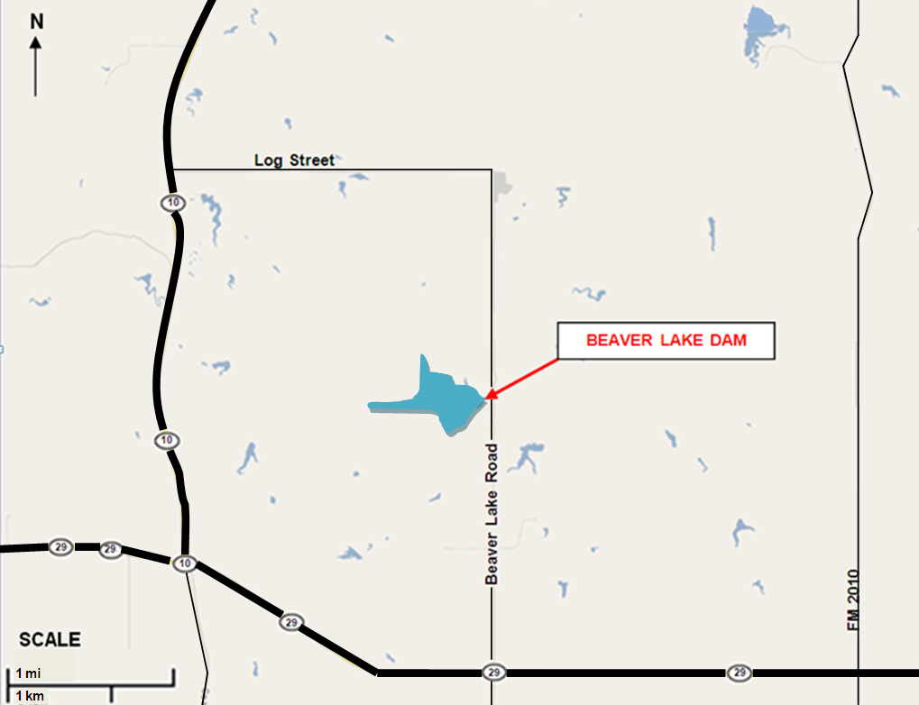
Example - Vicinity Map

Tab 2

Inundation Map
An inundation map is used to depict areas that could potentially flood if a dam fails. The inundation map should be used for evacuation planning. All dams require an inundation map, but the level of detail required on the map depends on the size of the dam and complexity of the floodplain conditions. Use the best available maps, including USGS topographic maps, county road maps, city street maps or maps from free internet mapping applications such as Google Maps, Bing, Yahoo, or Map Quest. At a minimum, the exhibit should include the features of one of the following types of inundation maps:
- Generalized Inundation Map (for dams with limited downstream development):
- Label the dam.
- Label all applicable street names.
- Label all applicable river/stream names.
- Include a north arrow.
- Scale the map appropriately to ensure all applicable features are visible. Include a scale bar.
- Use USGS topographic maps or aerial photography to show the affected areas of development.
- Label the potential hazards that could be affected by a dam failure.
- Call out affected roads and low-water crossings.
- Label potentially affected structures with street addresses.
- Detailed Inundation Map (For dams with significant numbers of structures downstream or complex floodplains. Typically prepared using the results of a breach analysis performed by a professional engineer):
Include items a-g from the “Generalized Inundation Map” section above.
- If the inundation area includes dense development, individual labels for affected structures are not required. Label developed areas, critical structures, and major roads as needed. (i.e. subdivision names, schools, hospitals, highways)
- Clearly delineate the boundary of the breach inundation area. Do not show any non-breach runs on the inundation map that is included with the EAP. For a full breach analysis, only show sunny day and design breach runs.
- If applicable, label the time to flood (time from the breach to the time critical structures and roads are flooded).
- If applicable, label the time to peak flow.
- Include a note that states “Because of the method, procedures, and assumptions used to determine the flooded areas; the limits of flooding shown and flood-wave travel times are approximate and should be used only as a guideline for establishing evacuation zones. Areas inundated in an actual event will depend on actual failure conditions and may differ from areas shown on the maps.”

Tab 3

Dam Description

Official Dam Name ⁽¹⁾:
Stream:
Dam Location:
Latitude/Longitude:
Dam Owner: Phone Number: ______________
Dam Owner’s Address:
Embankment
Type (ex.–earthen embankment)
Year Constructed
Length feet
Maximum Height feet
Top Width feet
Top of Embankment Elevation feet-msl
Drainage Area square miles

Principal Spillway ⁽²⁾
Type (ex.–Uncontrolled ogee weir)
Location (ex. - Right abutment)
Crest Length feet
Crest Elevation feet-msl

Emergency Spillway
Type (ex.–Excavated, broad-crested weir)
Location (ex.–Left abutment)
Crest Length feet
Crest Elevation feet-msl

Inlet-Outlet Works
Type
Location (ex.–Right end of the dam)
Invert Elevation (Inlet) feet-msl (bottom of pipe)
Invert Elevation (Outlet) feet-msl (bottom of pipe)

Reservoir
Elev. Top of Conservation Pool feet-msl
Capacity Conservation Pool (Normal Pool) acre-feet
Capacity at Top of Dam (Maximum) acre-feet
Surface Area acres

- If the dam is known by more than one name, it is recommended that all names be listed (i.e. Official TCEQ name, City name, common name known by locals, etc.)
- If the dam has multiple spillways, create additional subsections as necessary to include information on all spillways.

Tab 4

Sample Public Announcements
Note: These messages are communicated to downstream residents to alert the public of impending danger. The [Owner] should coordinate with the National Weather Service, the Department of Public Safety [Location] District Coordinator office, and the Emergency Management Coordinators for [AAA, BBB, and CCC county] prior to release. Messages developed with the assistance of the National Weather Service may be used instead, which can be communicated via radio, television, and other media outlets.

Announcement for a Slowly Developing “Watch” Condition
[Owner] has declared a “Watch” condition for [Name] Dam, Texas ID [TX#####] as of [time and date]. [Briefly describe the problem or condition.] There is no immediate danger of the dam failing; however the potential does exist. [Describe what actions are being taken to monitor and control the situation.] [State the quantity of any releases from the reservoir.]

Announcement for a Possible Dam Failure
This is an emergency message. [Owner] has declared a possible dam failure at [Name] Dam, Texas ID [TX#####] as of [time and date]. [Briefly describe the problem or condition.] It is possible the dam could fail. Attempts to save the dam are under way, but their success cannot be determined as yet. [Describe what actions are being taken to monitor and control the situation.] [State the quantity of any releases from the reservoir.] Additional news will be made available as soon as it is received.

Announcement for an Imminent Dam Failure
Urgent! This is an emergency message. [Owner] has announced that [Name] Dam, Texas ID [TX#####] is in imminent danger of failing. [Describe what actions are being taken to monitor and control the situation.] It is possible that the dam will fail in [##] hours. Residents in low lying areas along the [Stream], the [Stream], and the [Stream], as well as the town of [Name], should prepare for immediate evacuation. Additional news will be made available as soon as it is received.

Announcement of a Dam Failure
Emergency! This is an emergency message. [Name] Dam, Texas ID [TX#####] failed at [time and date]. Residents who have not yet done so should immediately evacuate the city of [Name] and low-lying areas along the [Stream], the [Stream], and the [Stream]. The flood waters have already reached [Highway] and [Road]. Additional news will be made available as soon as it is received.

Tab 5

Directory of Personnel
with Dam Safety Expertise
The following list identifies additional individuals with expertise in dam safety, design and construction, such as local engineers, contractors, and authorities that may be consulted about taking specific actions at the dam when there is an emergency situation. The TCEQ Dam Safety Section is not included in this section. TCEQ Dam Safety should be contacted during an emergency and can provide technical assistance by phone, but not immediate on-site assistance. TCEQ is not responsible for emergency evacuation.

NAME | TELEPHONE | RESPONSIBILITY

Tab 6

Supplies and Resources
The following equipment and supplies may be necessary for use during a dam emergency. Contact information for local contractors who can provide the following items during an emergency is listed below. For supplies owned by the dam owner, the dam owner’s name and the specific location of the supplies have been denoted.
EQUIPMENT/SUPPLIES | LOCATION
Backhoes  Dump trucks  Portable welding equipment  Generators  Bulldozers  Excavators  Loaders  Motor graders | [Names, addresses, and phone numbers  of contractors]
Crane | [Names, addresses, and phone numbers  of contractors]
Sandbags | [Names, addresses, and phone numbers  of suppliers]
Rock riprap | [Names, addresses, and phone numbers  of suppliers]
Fill Material | [Names, addresses, and phone numbers  of suppliers]
Other - | [Names, addresses, and phone numbers  of suppliers]

Tab 7

Annual EAP Evaluation Checklist
Was the annual dam inspection conducted? | □ Yes  □ No | If yes, has the EAP been revised to include any signs of failures observed during the inspection? | □ Yes  □ No
Was brush clearing, animal burrow removal, or other maintenance required? | □ Yes  □ No | If yes, describe actions taken and date:
Was the outlet gate operable? | □ Yes  □ No | If no, describe actions taken and date:
Do the Notification Flowcharts require revision?  (Note that revision of the contact information will not require EAP approval; however, the revised contact information pages will need to be redistributed as a replacement pages.) | □ Yes  □ No | If yes, list the dates of the contact information revision and redistribution:
Was annual training or an exercise conducted? | □ Yes  □ No | Circle: training exercise  Date conducted:
Are inspection and training records included in the EAP? | □ Yes  □ No
Was the EAP reviewed? | □ Yes  □ No | If yes, review date:
Were changes required to the EAP? | □ Yes  □ No | If yes, date of revised EAP approval:

[Name and Title of Appropriate Manager for Owner] Date

Tab 8

Plan Review and Update
This plan will be reviewed and updated annually and table top exercises will be conducted at least once every five years. Document these reviews below.
Date of review: Participants:
Date of review: Participants:
Date of review: Participants:
Date of review: Participants:
Date of table top exercise: Participants:

Tab 9

Training Record
Use this form to record training sessions. File the completed form in the appropriate Tab of the EAP. All items in the EAP should be thoroughly reviewed during training. Appropriate [Owner] employees and EAP team members should attend a training session annually (or participate in a simulated exercise).
TRAINING LOCATION:
DATE: TIME: INSTRUCTOR:

CLASS SIGN-IN:
Type of Simulation Conducted: | Circle Emergency Type:  Emergency water release  Watch condition  Possible dam failure  Imminent dam failure  Actual dam failure
Comments, Results of Exercise:

Revisions Needed to EAP Based on Results of Exercise?
□ Yes □ No If yes, list revisions required:

