Template for an
Emergency Action Plan
for a Large Dam

Revised 2019

[Name] Dam

[TX#####]

Emergency Action Plan

[Date]
Prepared for
[Name]
Prepared by
[Name]

[Name] Emergency Action Plan
[Name] Dam
[Owner], Inc.

Contents
Notification Flowchart (Watch Condition) [--]
Notification Flowchart (Possible, Imminent, or Dam Failure Condition) [--]
EAP Distribution List [--]
Log Sheet of Changes [--]
Approval and Implementation [--]
Emergency Action Plan [--]
- Purpose [--]
- Dam Description [--]
2.1. General [--]
2.2. Reservoir Operations [--]
- Responsibilities [--]
3.1. Dam Owner’s Responsibilities [--]
3.2. Responsibilities for Notification [--]
3.3. Emergency Operations Center [--]
3.4. Responsibilities for Evacuation [--]
3.5. Responsibilities for Duration, Security, Termination, and Follow-up [--]
3.6. Communications [--]
- Emergency Detection, Evaluation, and Classification [--]
4.1. Emergency Detection [--]
4.2. Emergency Evaluation and Classification [--]
4.3. Previously Known Problems [--]
- Preparedness [--]
- Supplies and Resources [--]
6.1. Contracts [--]
6.2. Equipment and Supplies [--]
6.3. Reports [--]
- Inundation Area [--]
7.1. Local Evacuation Plan [--]
- Implementation [--]
8.1. Development [--]
8.2. Updating [--]
8.3. Testing [--]
8.4. Training [--]
Tab 1 Vicinity Map [--]
Tab 2 Inundation Map [--]
Tab 3 Dam Description [--]
Tab 4 Sample Public Announcements [--]
Tab 5 Evidence of Distress [--]
Tab 6 Supplies and Resources [--]
Tab 7 Annual EAP Evaluation Checklist [--]

Tab 8 Plan Review and Update [--]
Tab 9 Training Record [--]

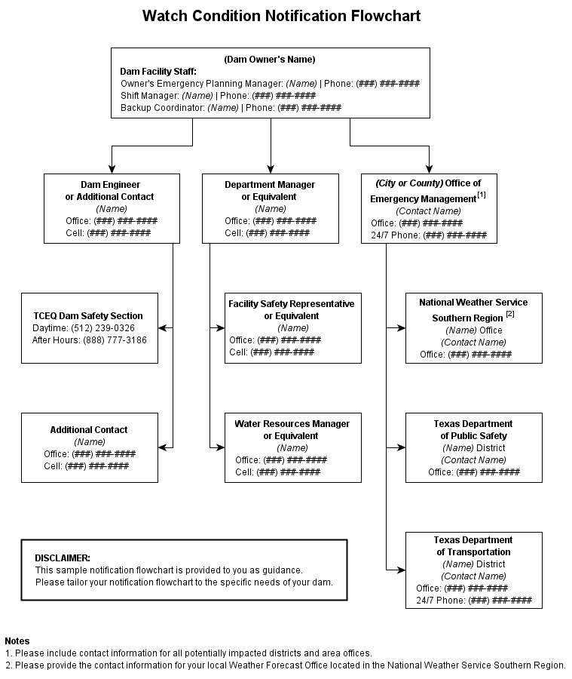

[Name] Dam, [TX#####]

EAP Distribution List
A copy of the EAP has been provided to the following individuals.
Authority | Name, Title, Phone | Address

Owner(s) and Representatives
Office of Emergency Management  [AAA County or AAA City] | Emergency Management Coordinator  [Name of Contact]  Phone ###-###-####
Texas Department of Transportation  District [###] | [Name of Contact]  Phone ###-###-####
Texas Commission  on Environmental Quality | (512) 239-0326 (daytime)  (888) 777-3186 (after hours) | Dam Safety Section, MC 177  P.O. Box 13087  Austin, TX 78711
Engineer  [Company Name] | [Name of Contact]  Phone ###-###-####
Note: Include information for all counties and districts within the inundation area.

[Name] Dam, [TX#####]

Log Sheet of Changes
Date | Change Made | Signature

Approval and Implementation

Emergency Action Plan

[Name] Dam, [TX#####]

This Emergency Action Plan is hereby approved. This plan is effective immediately and supersedes all previous editions.

[Name and Title of Appropriate Manager for Owner] Date

I have received a copy of this Emergency Action Plan and concur with the notification procedures.

[Name and Title of Emergency management Coordinator] Date

Emergency Action Plan

[Name] Dam, [TX#####]

1. Purpose
The purpose of this Emergency Action Plan (EAP) is to identify emergency situations that could threaten [Name] Dam and to plan for an expedited, effective response to prevent failure of the dam and warn downstream residents of impending danger. This plan defines the notification procedures to be followed in the event of a potentially hazardous situation. The procedures are intended to protect lives and prevent property damage from an uncontrolled release of water from the reservoir.

2. Dam Description

2.1. General
[Name] Dam and Reservoir are owned and operated by [Owner]. It is located on [Stream] in [Name] County, approximately [##] miles [direction] of [City], Texas. [Stream] is a tributary of the [Name of Main Tributary], located in the [Name] River Basin. The dam was completed in [year] and was constructed under Permit No. [####], Application No. [####], granted by the Texas Water Rights Commission to Owner in [year]. The lake was constructed to serve as [purpose].
A vicinity map showing the location of the dam can be found in Tab 1. An inundation map illustrating the areas subject to flooding as a result of a dam failure can be found in Tab 2. The inundation area is described in further detail in the Inundation Area section of the report. Lastly,
a description of the dam, its spillways, and other features are outlined in the Dam Description
in Tab 3.

2.2. Reservoir Operations
[The purpose of this section is to identify features and controls on the dam that would be used to release water and to explain how they would be implemented during an emergency. If the dam does not have any controls, the statement “Releases from the reservoir are uncontrolled” will suffice.]

3. Responsibilities

3.1. Dam Owner’s Responsibilities
The owner, [title], is responsible for all dam operation and maintenance. The EAP will not designate a specific person for a specific responsibility but instead will designate the person’s duties or job description.
The [Owner’s Emergency Planning Manager] is the first line of dam observers and is the person responsible for initiating implementation of the EAP.
The [title] is responsible for conducting routine dam maintenance, such as annual brush control, conducting dam integrity inspections, and notifying [title] of any potential emergency situations. The [title] is responsible for contacting emergency personnel should a dam failure be imminent.
The [title] is responsible for updating the EAP. An annual EAP review will be conducted to ensure that contact names and numbers are current on the Notification Flowcharts.
The [title] is responsible for directing specific, incident appropriate actions during an emergency, such as opening or closing water intakes and remedial construction activities such as dirt moving, etc. Specific scenarios are not listed in this EAP.

3.2. Responsibilities for Notification
The [title] is responsible for inspecting the dam in a potential emergency such as the potential threat of high waters or a tornado. The [title] will contact the [AAA County Sheriff or AAA City Police] and emergency management coordinator.
If warranted, the [title] will notify the TCEQ Dam Safety Section. The [AAA County Sheriff or AAA City Police] will notify downstream residents. The [AAA County or AAA City] emergency management coordinator will implement the Notification Flowchart for regional and state emergency management contacts.

3.3. Emergency Operations Center
In the event of a “possible dam failure” or more serious condition, the [Owner’s Emergency Planning Manager] will activate the Emergency Operations Center to serve as the main distribution center for warning and evacuation activities. The Emergency Operations Center will be established at the [location of office]. The [Owner’s Emergency Planning Manager] will be responsible for initiating actions from this location.

3.4. Responsibilities for Evacuation
The [AAA County Sheriff or AAA City Police] is responsible for initiating evacuations.

3.5. Responsibilities for Duration, Security, Termination, and Follow-up
The [title] is responsible for monitoring of emergency situations at the dam and keeping authorities informed, based on the Notification Flowcharts.
The [title] and the [title of emergency management coordinator] are responsible for declaring that an emergency at the dam is terminated. Applicable authorities will be notified based on the Notification Flowcharts.
The [title] will ensure that a follow-up evaluation is completed by all participants after the emergency. The results of the evaluation should be documented in a written report and filed with the EAP.

3.6. Communications
Local officials and downstream residents will be notified by landline telephone, if available; otherwise via cell phones or emergency personnel (in person or using their radios). The various radio networks for emergency use include the informal ham-radio network, and networks
belonging to:
The [AAA County Sheriff] or [AAA City Police]
The [BBB County Sheriff] or [BBB City Police]
The [CCC County Sheriff] or [CCC City Police]
The Texas Department of Public Safety
The Texas Department of Transportation
Sample public announcements appear in Tab 4. Verification or authentication of the situation can be made by contacting the Department of Public Safety District Coordinator office and the [AAA County], [BBB County], and [CCC County] and/or [City of AAA], [City of BBB], and [City of CCC] emergency management officials. Television and radio can be used as much as possible to notify area residents of the possible dangers. Public announcements are to be issued by the [Owner] public affairs officer.

4. Emergency Detection, Evaluation, and Classification

4.1. Emergency Detection

A. Situations
Many dam conditions can lead to emergency situations, not all of which will necessitate
the implementation of the EAP. However, if any of them occur, the appropriate actions must be taken.
Severe Storms/Inclement Weather: Although generally not in themselves a threat to the dam, severe storms and other inclement weather conditions can contribute to an existing problem and hinder any remediation efforts. Severe storms also cause the uncontrolled release of floodwater, and increase flow in already rain-swollen areas.
Tornadoes: Tornadoes do occur in the area, with the potential for structural damage to the dam, possibly resulting in its failure. If a tornado has struck in the area, an inspection of the dam for any signs of damage will be appropriate.
Earthquakes: [Dam Name] is located in a seismic zone with low activity. An earthquake is, however, a possibility, and appropriate post-earthquake inspections should be performed.
Sabotage: A threat to damage the dam has been made. Appropriate actions must be taken to protect the dam.

B. Signs of Failure
The [title] is responsible for conducting routine inspections and identifying conditions that could indicate the onset of problems leading to a dam failure. The early identification of potentially dangerous conditions can allow time for the implementation of EAPs. It is important to understand how distress can develop into failure. With appropriate action, distress need not lead to a catastrophic failure of the dam. The following sections describe some of the different types of failure which could lead to a dam failure.
Seepage Failure: Although all earthen embankments allow some minor seepage through the dam or the foundation, excessive, uncontrolled seepage can result in piping (the movement of embankment material in the seepage flow) and lead to failure. Piping can occur for years at a slow rate. If the piping has progressed to a dangerous level, it will be evident by increased flow or the discharge of muddy water (or both). At that stage, immediate action to stop the piping is needed. Fully developed piping is difficult to control and is very likely to result in failure. A whirlpool in the reservoir is a sign of uncontrollable piping and necessitates immediate emergency action.
Embankment or Foundation Sliding: Sliding is usually first apparent when cracks or bulges in the embankment appear. Slides with progressive movement can cause failure of the embankment.
Structural Failure: The structural failure or collapse of any portion of the principal spillway or spillway gates could result in loss of the reservoir. A structural failure of a portion of the spillway could cause piping and possibly embankment failure.
Overtopping Failure: Overtopping of the embankment results in erosion of the dam crest. Once erosion begins, it is very difficult to stop.

4.2. Emergency Evaluation and Classification
This section lists the conditions and actions which may be used to classify the level of emergency response, as a guide for the [Owner’s Emergency Planning Manager]. Specific dam observations
and corresponding emergency classification levels can be found in the Evidence of Distress
table in Tab 5.
Watch Condition: A problem has been detected at the dam which requires constant monitoring or immediate action to repair or correct. At this time, the distress condition is manageable by dam personnel.
The [Owner’s Emergency Planning Manager] will be responsible for monitoring and repair as soon as possible and implementing the appropriate Notification Flowchart. The following is a list of conditions which constitute “watch” conditions:
- cloudy or dirty seepage or seepage with an increase in flow, boils, piping, or bogs
- seepage around conduits
- large sinkholes with corresponding seepage anywhere on the embankment or downstream from the toe
- any slide that degrades the crest of the embankment or that is progressively increasing in size
- cracking or movement of any concrete structure
- the engagement of the emergency spillway
Possible Dam Failure Condition: A “watch” condition that is progressively getting worse. A situation is developing that could cause the dam to fail. Efforts to correct the situation will continue. There is no immediate danger; however, if conditions continue to deteriorate, the dam could fail.
The [Owner’s Emergency Planning Manager] will be responsible for initiating immediate repairs, including lowering the reservoir if appropriate and implementing the appropriate Notification Flowchart. The following is a list of conditions which constitute “possible dam failure” conditions:
- large boils, increasing in size and flow rate, especially if there is flowing muddy water
- significantly increasing seepage, especially flowing muddy water
- slides involving a large mass of material that impairs the crest of the dam and is continuing to move
- sinkholes with seepage flowing muddy water
- large cracks, movement or failure of a portion of any major concrete structure that forms an integral part of the dam
- an increase in the reservoir level to near the top of the dam
- overtopping of a dam that is not designed for overtopping
Imminent Dam Failure/Dam Failure Condition: The [Owner’s Emergency Planning Manager] has determined that a dam failure is occurring or has already occurred and will result in flooding that threatens life and property. No time remains to implement measures to prevent failure. Evacuation has begun and will continue until the situation is stabilized.
The [Owner’s Emergency Planning Manager] is responsible for implementing the appropriate Notification Flowchart. The following is a list of conditions which constitute “imminent dam failure” or “dam failure” conditions:
- rapidly increasing boils or the presence of new, significantly flowing boils, particularly muddy ones near previously identified ones
- rapidly increasing seepage, especially flowing muddy water
- slides involving a large mass of material or which have degraded the crest of the embankment to a level that approaches the water surface level, or if significant seepage is observed through the slide area
- settlement that is predicted to degrade to the reservoir level
- cracks that extend to the reservoir level
- significant movement or failure of any structure that forms an integral part
of the dam
- overtopping of an earthen dam
- uncontrollable release of the reservoir

4.3. Previously Known Problems
[Identify any known problems with the dam such as those outlined in previous dam safety inspections.]

5. Preparedness
Preparedness actions are to be taken both before and following the development of emergency conditions and should identify ways of preparing for an emergency, increasing response readiness in a uniform and coordinated manner, and helping to reduce the effects of a dam failure. The following are some steps that could prevent or delay failure after an emergency is first discovered.
Surveillance: [title] will monitor the dam during emergency situations such as a severe storm event.
Response during weekends and holidays: [title] will be available for emergency response during weekends and holidays and can be present at the dam site within [# minutes] of detection of an emergency condition.
Response during periods of darkness and adverse weather: [title] will arrange for access to generators and lights to adequately monitor the situation. [title] will be able to access the site during adverse weather conditions by [method of access - i.e. foot, utility vehicle, etc.].
Access to the site: Alternate access routes should be planned in the event of an emergency at the dam. [Example: The road across the dam is a gravel roadway with grassed edges which should allow discharge across the road rendering this route inaccessible. The north and east alternate routes should be used instead under such conditions. All-weather access to the downstream toe of the dam will also be unavailable. For developing situations near the downstream toe of the dam, gravel may need to be brought in to stabilize a road in that area.]
Preventive measures can be taken in an emergency to prevent the catastrophic failure of the dam, but such repairs should be undertaken with extreme caution. The repairs are only temporary, and a permanent repair should be designed by an engineer as soon as possible.
The following actions should only be undertaken under the direction of a professional engineer or contractor. In all cases, the appropriate Notification Flowchart must be implemented and the personnel of the TCEQ Dam Safety Section must be notified.
Consider the following preparedness actions if the dam’s integrity is threatened by:

Seepage Failure
Plug the flow with whatever material is available (hay, bentonite, or plastic) if the entrance is in the reservoir.
Lower the water level in the reservoir by using the low flow outlet and pumping if necessary, until the flow decreases to a non-erosive velocity or until it stops. Place an inverted filter (a protective layer of sand and gravel) on the exit area to hold the material
in place.
Continue operating at a lower level until a repair is made.

Embankment or Foundation Sliding
- Lower the water level in the reservoir by pumping if necessary at a rate and to an elevation considered safe, given the slide condition.
- Stabilize the slide, if on the downstream slope, by weighting the toe area below the slide with soil, rock, or gravel.
- Continue operating at a lower level until a repair is made.

Structural Failure
- Implement temporary measures to protect the damaged structure, such as placing rock riprap in the damaged area.
- Lower the water level to a safe elevation through the low flow release valve and by pumping if necessary.

6. Supplies and Resources

6.1. Contracts
Should [Owner] personnel and resources prove to be inadequate during an emergency, requests will be made for assistance from other local jurisdictions, other agencies, and industry, as needed. Such assistance may include equipment, supplies, or personnel. All agreements will be entered into by authorized officials and should be in writing whenever possible. The [Owner’s Emergency Planning Manager] shall have the authority to enter into agreements as deemed necessary to prevent the failure of the dam.

6.2. Equipment and Supplies
Equipment that is available for use and local contractors that can be contacted to provide equipment during an emergency event are listed in Tab 6.

6.3. Reports

Technical Data
Periodic inspections of the dam will be made to evaluate its structural safety, stability, and operational adequacy. In the event of an abnormal occurrence, reference to these reports, particularly the photographs, can be beneficial in the evaluation of a potential problem.
Technical records such as drawings and inspection reports should be stored and carefully maintained at the [Owner] Site offices. Alternate personnel will be familiar with the location of the documents in the event of an emergency situation.

Emergency Operations Center Activity Log
Any unusual or emergency condition should be documented, including the following:
activation or deactivation of emergency facilities
emergency notifications to other local governments and to state and federal agencies
significant changes in the emergency
major commitments of resources or requests for additional resources from
external sources
telephone calls should be recorded in chronological order
issuance of protective action recommendations to the public
evacuations
casualties
termination of the incident

Costs of the Emergency Operations Center
For major emergencies, the emergency operations center will maintain detailed records of costs expended. These records may be used to recover costs from the responsible party or insurers, or as a basis for requesting financial assistance for certain allowable response and recovery costs from the state or federal government. Documented costs should include:
personnel costs, especially overtime
equipment operation
equipment leasing and rental
contract services to support emergency operations
specialized supplies expended in emergency operations

7. Inundation Area
The inundation map illustrates the areas subject to flooding from a failure of the dam, and can be found in Tab 2. Also included on the map are the times to flood associated with bridge crossings. The map was prepared using the results of a full breach analysis. Refer to Tab 4 for public announcements (notification message) for various watch/failure conditions.
After examining the results of the breach analysis of [Name] Dam, it has been determined that there were a significant number of structures that could be affected due to a design flood or sunny-day dam breach. These structures are located along the [Stream], the [Stream], and the [Stream]. [City or Town] can suffer a dramatic impact from a breach of the dam. In addition, water resulting from a breach, and associated damages, can, under certain circumstances, travel down the [Stream].
The breach analysis contains profiles of the peak flood levels expected, as well as an estimation of the time from the beginning of the breach to the peak flood elevations. A comparison of the areas that are likely to be flooded with the plots showing the times from the start of the breach to the flooding shows the areas of evacuation and the time constraints involved. Figures in the breach analysis include information on the estimated impact of flooding on the bridges along the [Stream], the [Stream], and the [Stream]. These structures may suffer such impacts before the peak elevation of the flood wave.

7.1. Local Evacuation Plan
If imminent failure of the dam with uncontrolled downstream flooding is anticipated, local emergency management and law enforcement personnel should notify those downstream of evacuation in the most expedient manner possible. The organizations and personnel on the Notification Flowchart should be contacted immediately. Local law enforcement officials, along with radio and television stations, can best spread the notice for evacuation. The immediate impact will be to areas along [Stream] downstream of the dam. For sunny-day and design flood breaches, the following actions should be taken:
Barricading all bridges that could possibly be flooded to prevent access to the affected area. These bridges include the [Stream] crossings of [Highway or Road]. See the Inundation Map in Tab 2 to determine appropriate barricade locations.
The Department of Public Safety District Coordinator office can assist with the notification of all persons and agencies involved, with the possibility of additional support—including contacting others not accessible by radio or telephone.
County officials are generally familiar with developed areas in their jurisdiction. Such knowledge, coupled with the requirements of state law that they respond to disasters, make them the logical officials to be notified and to spread the warning message to all areas subject to flooding.

8. Implementation

8.1. Development
The draft EAP was sent to the TCEQ for review, and agency comments were incorporated into this document, a copy of which is currently on file with TCEQ.

8.2. Updating
Copies of the EAP have been provided to the appropriate individuals and the EAP has been approved and signed by the owner and emergency management coordinator, as shown on the Distribution List and Approval and Implementation sheets at the front of the report. This plan will be reviewed and updated annually by [Owner’s Emergency Planning Manager] and personnel from local emergency management agencies in conjunction with [Owner’s Emergency Planning Manager]’s annual maintenance inspection of the dam. The [Owner’s Emergency Planning Manager] will review and complete all items on the Annual EAP Evaluation Checklist in Tab 7. After the annual update is complete, a new Approval and Implementation sheet will be attached and the annual update will be documented on the Plan Review and Update sheet in Tab 8.
If revisions to the EAP are made as a result of the annual update, such changes will be recorded on the Log Sheet of Changes form at the front of the report. A copy of the updated portions of the EAP will be sent to TCEQ. If the EAP was reviewed and revisions were not required, the [Owner] will submit written notification to the TCEQ that no updates to the EAP have been adopted or implemented.

8.3. Testing
A table top exercise will be conducted at least once every five years. The table top exercise involves a meeting of [Owner’s Emergency Planning Manager] with local and state emergency management officials in a conference room. The exercise begins with a description of a simulated event and proceeds with discussions by the participants to evaluate the EAP and response procedures, and to resolve concerns regarding coordination and responsibilities. Any problems identified during an exercise should be included in revisions to the EAP. Records of training and testing exercises will be resolved and maintained in Tab 9.

8.4. Training
All people involved in the EAP will be trained to ensure that they are thoroughly familiar with its elements, the availability of equipment, and their responsibilities and duties under the plan. Personnel will be trained in problem detection, evaluation, and appropriate corrective measures. This training is essential for proper evaluation of developing situations at all levels of responsibility. Training records will be maintained in Tab 9.

Tab 1

Vicinity Map
The purpose of the vicinity map is to show the location of the dam and surrounding roads that provide access to the dam. USGS topographic maps, county road maps, city street maps, or free Internet mapping applications such as Google Maps, Bing, Yahoo, or Map Quest can be used to produce the vicinity map. An example is shown below.
The vicinity map must include the following features:
- Show the location of the dam in relation to major roads (highways, farm to market, county roads, etc.), intersections, and landmarks in the area.
- Label all applicable street names.
- Label the dam.
- Include a north arrow.
- Scale the map appropriately to ensure all applicable features are visible. Include
a scale bar.

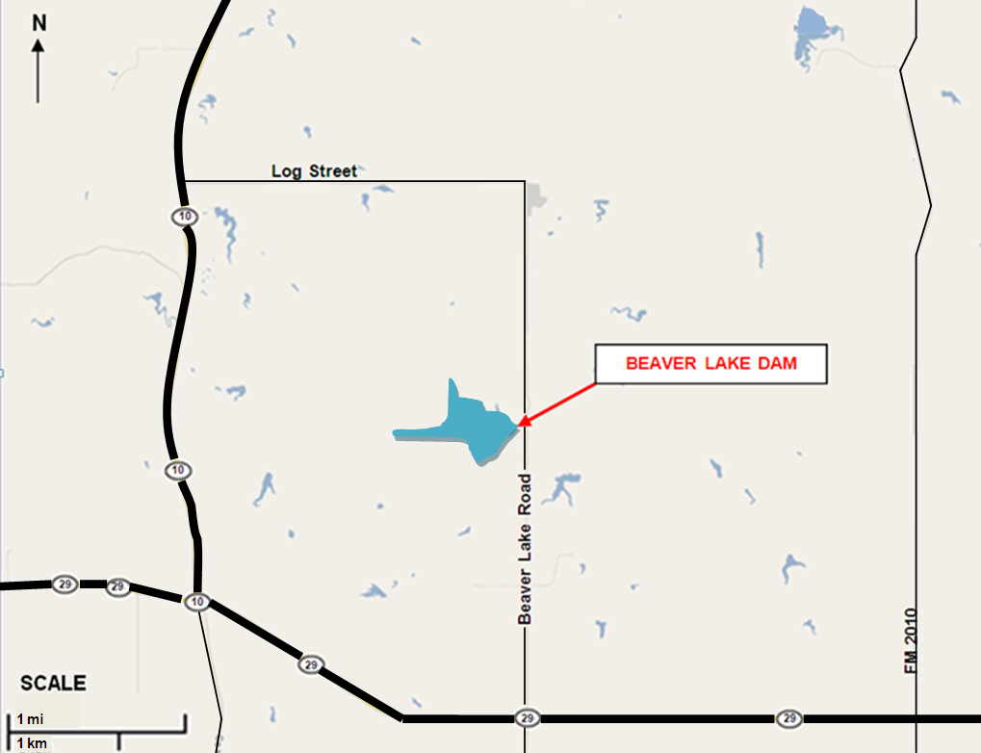
Example - Vicinity Map

Tab 2

Inundation Map
An inundation map is used to depict areas that could potentially flood if a dam fails. The inundation map should be used for evacuation planning. All dams require an inundation map, but the level of detail required on the map depends on the size of the dam and complexity of the floodplain conditions. Use the best available maps, including USGS topographic maps, county road maps, city street maps, aerial photography, and other sources of topographic information. At a minimum, the inundation map for a large dam must include:
Detailed Inundation Map (For dams with significant numbers of structures downstream or complex floodplains. Must be prepared using the results of a full breach analysis performed by a professional engineer):
- Label the dam.
- Label all applicable street names.
- Label all applicable river/stream names.
- Include a north arrow.
- Scale the map appropriately to ensure all applicable features are visible. Include a scale bar.
- Use USGS topographic maps, aerial photography, and other sources of topographic information to show the affected areas of development.
- Label the potential hazards that could be affected by a dam failure.
- Call out affected roads and low-water crossings.
- Label potentially affected structures with street addresses. If the inundation area includes dense development, individual labels for affected structures are not required. Label developed areas, critical structures, and major roads as needed. (i.e. subdivision names, schools, hospitals, highways)
- Clearly delineate the boundary of the breach inundation area. Do not show any non-breach runs on the inundation map that is included with the EAP. Only show sunny day and design breach runs.
- Label the time to flood (time from the breach to the time critical structures and roads are flooded).
- Label the time to peak flow.
- Include a note that states “Because of the method, procedures, and assumptions used to determine the flooded areas; the limits of flooding shown and flood wave travel times are approximate and should be used only as a guideline for establishing evacuation zones. Areas inundated in an actual event will depend on actual failure conditions and may differ from areas shown on the maps.”

Tab 3

Dam Description
Official Dam Name ⁽¹⁾:
Dam Location:
Latitude/Longitude:
Dam Owner: Phone Number:
Dam Owner’s Address:
Embankment
Type (ex.–earthen embankment)
Year Constructed
Length feet
Maximum Height feet
Top Width feet
Top of Embankment Elevation feet-msl
Drainage Area square miles

Principal Spillway ⁽²⁾
Type (ex.–Uncontrolled ogee weir)
Location (ex.–Right abutment)
Crest Length feet
Crest Elevation feet

Emergency Spillway
Type (ex.–Excavated, broad-crested weir)
Location (ex.–Left abutment)
Crest Length feet
Crest Elevation feet-msl

Inlet-Outlet Works
Type
Location (ex.–Right end of the dam)
Invert Elevation (Inlet) feet-msl (bottom of pipe)
Invert Elevation (Outlet) feet-msl (bottom of pipe)

Reservoir
Elev. Top of Conservation Pool feet-msl
Capacity Conservation Pool (Normal Pool) acre-feet
Capacity at Top of Dam (Maximum) acre-feet
Surface Area acres

- If the dam is known by more than one name, it is recommended that all names be listed (i.e. Official TCEQ name, City name, common name known by locals, etc.)
- If the dam has multiple spillways, create additional subsections as necessary to include information on all spillways.

Tab 4

Sample Public Announcements
Note: These messages are communicated to downstream residents to alert the public of impending danger. The [Owner] should coordinate with the National Weather Service, the Department of Public Safety [Location] District Coordinator office, and the Emergency Management Coordinators for [AAA, BBB, and CCC County] prior to release. Messages developed with the assistance of the National Weather Service may be used instead, which can be communicated via radio, television, and other media outlets.

Announcement for a Slowly Developing “Watch” Condition
[Owner] has declared a “Watch” condition for [Name] Dam, Texas ID [TX#####] as of [time and date]. [Briefly describe the problem or condition.] There is no immediate danger of the dam failing; however the potential does exist. [Describe what actions are being taken to monitor and control the situation.] [State the quantity of any releases from the reservoir.]

Announcement for a Possible Dam Failure
This is an emergency message. [Owner] has declared a possible dam failure at [Name] Dam, Texas ID [TX#####] as of [time and date]. [Briefly describe the problem or condition.] It is possible the dam could fail. Attempts to save the dam are under way, but their success cannot be determined as yet. [Describe what actions are being taken to monitor and control the situation.] [State the quantity of any releases from the reservoir.] Additional news will be made available as soon as it is received.

Announcement for an Imminent Dam Failure
Urgent! This is an emergency message. [Owner] has announced that [Name] Dam, Texas ID [TX#####] is in imminent danger of failing. [Describe what actions are being taken to monitor and control the situation.] It is possible that the dam will fail in [##] hours. Residents in low lying areas along the [Stream], the [Stream], and the [Stream], as well as the town of [Name], should prepare for immediate evacuation. Additional news will be made available as soon as it is received.

Announcement of a Dam Failure
Emergency! This is an emergency message. [Name] Dam, Texas ID [TX#####] failed at [time and date]. Residents who have not yet done so should immediately evacuate the city of [Name] and low-lying areas along the [Stream], the [Stream], and the [Stream]. The flood waters have already reached [Highway] and [Road]. Additional news will be made available as soon as it is received.

Tab 5

Evidence of Distress
General Observation | Specific Observation | Condition | Emergency Action | Equipment, Material and Supplies | Data to Record
Boils | Small boils, no increase of water flow, flowing clear water | Watch | Closely check all of downstream toe, especially in the vicinity of boil for additional boils, wet spots, sinkholes, or seepage. Closely monitor entire area for changes or flow rate increases. | None | Site and location, approximate flow
 | Large or additional boils near previously identified ones, without increasing flow rate, but carrying small amount of soil particles | Watch | Initiate 24-hour surveillance. Monitor as described above. Construct sandbag ring dikes around boils, to cover them with water to retard the movement of soil particles. Filter cloth may be used to retard soil movement, but do not retard the flow of water. | Sandbags, filter cloth | Site and location, approximate flow
 | Large or additional boils near previously identified ones, increasing flow rate, carrying soil particles | Possible Failure | Continue 24-hour surveillance. Continue monitoring and remedial action as described above. Initiate emergency lowering of the reservoir. Issue a warning to downstream residents. | Sandbags, pump | Site and location, approximate flow
 | Rapidly increasing size of boils and flow increasing and muddy water | Imminent Failure | Downstream evacuation. Employ all available equipment to attempt to construct a large ring dike around the boil area. | Dozer, shovels, source of earthfill | Site and location, approximate flow
Seepage | Minor seepage of clear water at toe, on slope of embankment, or at the abutments | Watch | Closely check entire embankment for other seepage areas. Use wooden stakes or flagging to delineate seepage area. Try to channel and measure flow. Look for upstream whirlpools. | Wooden stakes, flagging | Site, location, approximate flow
 | Additional seepage areas observed flowing clear water and/or increasing flow rate. | Watch | Initiate 24-hour surveillance. Monitor as described above. Construct measuring weir and channel all seepage through weir. Attempt to determine source of seepage. | Dozer, shovels | Site, location, approximate flow
 | Seriously or rapidly increasing seepage, underseepage, or drain flow. | Possible Failure | Continue 24-hour monitoring and remedial action as described above. Initiate emergency lowering of the reservoir. Construct a large ring dike around the seepage area. | Dozer, shovels, source of earthfill | Site location, approximate flow
 | Additional seepage areas with rapid increase in flow and muddy water. | Imminent Failure | Downstream evacuation. Employ all available equipment to attempt to construct a large ring dike around the seepage area. | Dozer, shovels, source of earthfill | Site location, approximate flow

Tab 5 (continued)

Evidence of Distress
General Observation | Specific Observation | Condition | Emergency Action | Equipment, Material and Supplies | Data to Record
Slides or severe erosion | Skin slide or slough on slope of embankment. No further movement of slide and embankment crest not degraded. | Watch | Examine rest of embankment for other slides. Place stakes in slide material and adjacent to it for determining if further movement is taking place. | Stakes, tape measure | Distance between stakes
 | Slide or erosion involving large mass of material, crest of embankment is degraded, no movement or very slow continuing movement. | Watch | Initiate 24-hour surveillance. Mobilize all available resources and equipment for repair operations to increase freeboard and to protect the exposed embankment material. Start filling sandbags and stockpile near slide area. | Dozer, shovels, sources of earthfill, sandbags | Distance between stakes
 | Slide or erosion involving large mass of material, crest of embankment is degraded, progressively increasing in size. | Possible Failure | Continue monitoring and remedial actions as described above. Place additional material at the toe of the slope to stop the slide. | Dozer, shovels, source of earthfill, pump | Distance between stakes
 | Slide or erosion involving large mass  of material, crest of embankment is severely degraded, movement of slide is continuing and may reach pool level. | Imminent Failure | Downstream evacuation. Utilize all available equipment and personnel to sandbag the degraded slide area to prevent it from overtopping. | Dozer, shovels, sandbags, pump | Distance between stakes
Sinkholes | Sinkholes anywhere  on the embankment  or within 500 feet downstream from  the toe. | Watch | Carefully walk the entire embankment and downstream area looking for additional sinkholes, movement, or seepage. | Stakes, flagging | Size, location
 | Sinkholes with corresponding seepage anywhere on the embankment or downstream from  the toe. | Watch | Initiate 24-hour surveillance. Monitor as above. Construct sandbag dike around the seepage exit point to reduce the flow rate. Start filling sandbags and stockpile near sinkhole. | Dozer, shovels, pump | Size, location
 | Large sinkholes with corresponding seepage anywhere on the embankment or downstream from  the toe. | Possible failure | Continue monitoring and remedial action as described above. Utilize sandbags to increase the freeboard on the dam if necessary. | Sandbags, dozer, pump | Size, location
 | Sinkholes rapidly getting worse, seepage flowing muddy water and increasing flow. | Imminent failure | Downstream evacuation. Utilize all available equipment and personnel to attempt to construct a large ring dike around the area. | Dozer, shovels, pump | Size, location

Tab 5 (continued)

Evidence of Distress
General Observation | Specific Observation | Condition | Emergency Action | Equipment, Material and Supplies | Data to Record
Settlement | Obvious settlement  of the crest of the embankment, especially adjacent to concrete structures. | Watch | Look for bulges on slope or changes in  crest alignment. | None | Size, location
 | Settlement of crest of embankment that is progressing, especially adjacent to concrete structures or if any corresponding seepage is present. | Watch | Initiate 24-hour surveillance. Mobilize all available resources for repair operations to increase freeboard. Fill and stockpile sandbags. Identify any boils near settlement points for flowing material and pursue  action for boils. | Sandbags, dozer, shovels, source of earthfill | Size, location
 | Settlement of crest of embankment that is rapidly progressing especially adjacent to concrete structures  or if any corresponding seepage is flowing muddy water or increasing flow. | Possible failure | Continue monitoring and remedial actions as described above. Use sandbags to increase the freeboard on the dam if necessary. | Sandbags, shovels, dozer, source of earthfill | Size, location
 | Progressing settlement that is expected to degrade the embankment to reservoir level. | Imminent failure | Downstream evacuation. Utilize all available equipment and personnel to build up the crest in the area that is settling. Identify any boils near settlement points for flowing material and pursue action for boils. | Dozer, shovels, source of earthfill, sandbags | Size, location
Cracking | Cracks in the embankment crest  or on slopes. | Watch | Walk on entire crest and slope and check for additional cracking. | Stakes, tape measure | Size, location
 | Numerous cracks in crest that are enlarging, especially those perpendicular to the centerline of the dam. | Watch | Initiate 24-hour surveillance. Carefully monitor and measure cracking to determine the speed and extent of the problem. Mobilize to fill cracks. Cracks parallel to the centerline indicate a slide. Follow remedial action  for slides. | Stakes, tape measure, dozer, shovels, source of earthfill | Size, location
 | Large cracks in the  crest that are rapidly enlarging, especially those perpendicular  to the centerline of  the dam. | Possible failure | Continue monitoring and remedial action  as described above. | Dozer, shovels, source of earthfill | Size, location
 | Cracking that extends  to pool elevation. | Imminent failure | Downstream evacuation. Continue remedial actions as described above. | Dozer, shovels, source of earthfill | Size, location

Tab 5 (continued)

Evidence of Distress

General Observation | Specific Observation | Condition | Emergency Action | Equipment, Material and Supplies | Data to Record
Cracking or movement of concrete structure | Minor cracking and/or movement. | Watch | Immediately install measuring device to monitor movement. | Crack Monitors, stakes, tape measure | Size, location
 | Significant cracking and/or movement. | Watch | Initiate 24-hour surveillance. Lower burlap on upstream face of crack to reduce flow of soil particles. Dump rockfill downstream of moving concrete structure monolith to resist the movement. | Burlap, rockfill, dozer, shovels | Size, location, flow rate
 | Serious cracking and/or movement | Possible failure | Continue monitoring and remedial action as described above. | Dozer, rockfill, burlap, crack monitors | Size, movement, flow rate
 | Major cracking and/or movement | Imminent failure | Downstream evacuation. Continue monitoring and remedial actions as described above. | Dozer, shovels, rockfill | Size, location, flow rate
Upstream Whirlpool | Whirlpool in the lake  in the vicinity of the embankment | Imminent Failure | Downstream evacuation. Attempt to plug the entrance of the whirlpool with riprap from the slope of the embankment. Search downstream for an exit point and construct a ring dike to retard the flow of soil particles. | Dozer, source of earthfill, sandbags, filter cloth, straw, rocks | Size, location, flow rate
Broken gate | Structural member of  a gate or gate operator broken or severely damaged so as to prevent operation  of the gate | Possible failure | Initiate 24-hour surveillance. Immediately place stop logs in front of gate and initiate necessary actions to get gate repaired. | Crane and welder | Type of problem, location
Rapidly rising lake | Lake level rising and rain continuing | Watch | Initiate 24-hour surveillance of lake level and rainfall. |  | Lake level, rainfall
Dam being overtopped | Water flowing over  the dam and lake continuing to rise | Possible failure | Downstream evacuation. Continue monitoring. |  | Lake level, rainfall

Tab 6

Supplies and Resources
The following equipment and supplies may be necessary for use during a dam emergency. Contact information for local contractors who can provide the following items during an emergency is listed below. For supplies owned by the dam owner, the dam owner’s name and the specific location of the supplies have been denoted.
EQUIPMENT/SUPPLIES | LOCATION
Backhoes  Dump trucks  Portable welding equipment  Generators  Bulldozers  Excavators  Loaders  Motor graders | [Names, addresses, and phone numbers  of contractors]
Crane | [Names, addresses, and phone numbers  of contractors]
Sandbags | [Names, addresses, and phone numbers  of suppliers]
Rock riprap | [Names, addresses, and phone numbers  of suppliers]
Fill Material | [Names, addresses, and phone numbers  of suppliers]
Other - | [Names, addresses, and phone numbers  of suppliers]

Tab 7

Annual EAP Evaluation Checklist
Was the annual dam inspection conducted? | □ Yes  □ No | If yes, has the EAP been revised to include any signs of failures observed during the inspection? | □ Yes  □ No
Was brush clearing, animal burrow removal, or other maintenance required? | □ Yes  □ No | If yes, describe actions taken and date:
Was the outlet gate operable? | □ Yes  □ No | If no, describe actions taken and date:
Do the Notification Flowcharts require revision?  (Note that revision of the contact information will not require EAP approval; however, the revised contact information pages will need to be redistributed as a replacement pages.) | □ Yes  □ No | If yes, list the dates of the contact information revision and redistribution:
Was annual training or an exercise conducted? | □ Yes  □ No | Circle: training exercise  Date conducted:
Are inspection and training records included in the EAP? | □ Yes  □ No
Was the EAP reviewed? | □ Yes  □ No | If yes, review date:
Were changes required to the EAP? | □ Yes  □ No | If yes, date of revised EAP approval:

[Name and Title of Appropriate Manager for Owner] Date

Tab 8

Plan Review and Update
This plan will be reviewed and updated annually and table top exercises will be conducted at least once every five years. Document these reviews below.
Date of review: Participants:
Date of review: Participants:
Date of review: Participants:
Date of review: Participants:
Date of tabletop exercise: Participants:

Tab 9

Training Record
Use this form to record training sessions. File the completed form in the appropriate Tab of the EAP. All items in the EAP should be thoroughly reviewed during training. Appropriate [Owner] employees and EAP team members should attend a training session annually (or participate in a simulated exercise).
TRAINING LOCATION
DATE: TIME: INSTRUCTOR:
CLASS SIGN-IN:
Type of Simulation Conducted: | Circle Emergency Type:  Emergency water release  Watch condition  Possible dam failure  Imminent dam failure  Actual dam failure
Comments, Results of Exercise:

Revisions Needed to EAP Based on Results of Exercise?
□ Yes □ No If yes, list revisions required:

