Texas Commission on Environmental Quality

Production Area Authorization
For In-Situ Uranium Mining

Instructions
- To produce uranium from subsurface deposits, an operator must obtain an Area Permit and production area authorization (PAA) pursuant to the Texas Water Code (TWC), Chapter 27. If the operator of the facility is not the owner, then the operator shall be the applicant for an Area Permit. The applicant is referred to Title 30 of the Texas Administrative Code (TAC) Chapters 281, 305 and 331 for technical and procedural regulations. Handling and storage of radioactive materials and disposal of by-product material must be authorized by a Radioactive Material license in accordance with TAC Chapter 336.
- The website listed in the footnote below contains the rules a person (individual, corporation or other legal entity) who intends to operate an underground injection activity must follow Title 30 Texas Administrative Code (TAC)1.
- A person may not commence underground injection activities for the purpose of leaching or otherwise recovering uranium until the Commission has issued an Area Permit and PAA to authorize such activities, and all portions of the proposed production zone in groundwater with a total dissolved solids concentration less than 10,000 mg/L, that will be affected by mining solutions are included within an aquifer exemption approved by the Commission and Environmental Protection Agency (EPA). The PAA application may be developed concurrently with or after the Area Permit application. As additional production areas are proposed to be activated within the Area Permit, additional PAA applications shall be submitted to the Commission for processing and issuance before injecting within the production area.
- The application (one original plus two complete copies) should be delivered to the following mailing address or physical address:

Mailing address:
Texas Commission on Environmental Quality
Attn: Radioactive Materials Section Uranium Licensing and Permitting
Radioactive Materials Division
Mail Code: 233
P.O Box 13087
Austin Texas 78711 3087
Physical address:
Texas Commission on Environmental Quality
Attn: Radioactive Materials Section Uranium Licensing and Permitting
Radioactive Materials Division
Mail Code: 233
12100 Park 35 Circle Building F
Austin Texas 78753

1 http://texreg.sos.state.tx.us/public/readtac$ext.viewtac

Additionally, for new, major amendment, and minor amendment applications, provide a CD or DVD of the application text, figures, and maps formatted in Microsoft Office Word 2010 or a totally compatible format.
Telephone inquiries:
(512) 239-6466 - Technical, Permitting, and Licensing – Radioactive Materials Division
(512) 239-0600 - Legal - Environmental Law Division
(512) 239-0300 - Fees - Financial Administration Division
(512) 239-6833 - Registration and Reporting Section
(512) 239-6239 - Financial Assurance - Financial Assurance Section
- The application consists of 4 sections: Section I - General Information, Section II – Information Required to Provide Notice, Section III - Financial Assurance and Liability, and Section IV - Technical Report. The Technical Report addresses geology, hydrology, well logs, construction, cross-sections, mine plan, groundwater analysis, and restoration.
Information submitted should be organized and labeled consistent with the organization of this form. For example, responses and discussion relating to financial assurance requirements should be labeled as Section III and the Technical Report should be labeled as Section IV. The application should be organized in three-ring binders not to exceed three inches in thickness. All pages should be numbered and placed in the binders. Once the application is submitted, any revised text, tables, or maps should be clearly marked as revisions and dated. A new signature page is required for each revision. Any new pages, tables, figures, maps, or well logs should be clearly marked as additions and numbered or labeled appropriately for insertion into the application.
For a new PAA application [30 TAC 305 Subchapter C] submit:
- an original complete application, plus two (2) full paper copies;
- a CD or DVD of the application text; and
- a check for payment of permit application fees transmitted directly to the TCEQ Financial Administration Division with a photostatic copy of the check included in the original application.
For a PAA major amendment application [30 TAC §305.62(c)(1)], submit:
- an original application, plus two (2) paper copies;
- the application must include Section I, the Signature Page and Section II plus any other portion of the application that changes as a result of the major amendment;
- a CD or DVD of the application text; and
- a check for payment of permit application fees transmitted directly to the TCEQ Financial Administration Division with a photostatic copy of the check included in the original application.
For a PAA minor amendment application [30 TAC §305.62(c)(2)], submit:
- an original application, plus two (2) paper copies;
- the application must include Section I.A through L, the Signature Page, and Section II plus any other portion of the application that changes as a result of the minor amendment;
- a CD or DVD of the application text; and
- a check for payment of permit application fees transmitted directly to the TCEQ Financial Administration Division with a photostatic copy of the check included in the original application.
For a PAA minor modification application [30 TAC §305.72], submit:
- an original application, plus two (2) paper copies;
- the application must include Section I.A through L and the Signature Page plus any other portion of the application that changes as a result of the minor modification; and
- a check for payment of permit application fees transmitted directly to the TCEQ Financial Administration Division with a photostatic copy of the check included in the original application.
For a PAA transfer application [30 TAC §305.64], submit:
- an original application, plus two (2) paper copies, submitted at least 30 days before the proposed transfer date [30 TAC 305.64(b)];
- the application must include Section I.A through L, the Signature Page, Section II and Section III;
- the date of the proposed transfer;
- if the permittee is filing the application, the transferee name, address, contact name, and phone number;
- if the transferee is filing the application, a sworn statement that the application is made with the full knowledge and consent of the permittee; and
- a check for payment of permit application fees transmitted directly to the TCEQ Financial Administration Division with a photostatic copy of the check included in the original application.
For a PAA endorsement application [30 TAC § 50.145], submit:
a) an original application, plus two (2) paper copies;
b) the application must include Section I.A through L and the Signature Page plus any other portion of the application that changes as a result of the endorsement;
c) if endorsement is changing the permittee name, submit verification from the Secretary of State that a name change alone has occurred (if an ownership change has occurred, submit an application for transfer rather than for an endorsement); and
d) a check for payment of permit application fees transmitted directly to the TCEQ Financial Administration
- Signatures on Application: Refer to 30 TAC §305.44, “Signatories to Applications.” The application must be signed by the applicant and be verified before a notary public. If another person signs on behalf of the applicant, this person's title or relationship to the applicant should be shown. In all cases, the person signing the form should be authorized to do so by the applicant. The Commission may require a person signing on behalf of an applicant to provide proof of authorization. An application submitted for a corporation must be signed by (or the signatory must be authorized by) a principal executive officer of at least the level of vice president; or for a partnership or sole proprietorship, by a general partner or the proprietor, respectively. For a municipal, state, federal, or other public facility, the application must be signed by either a principal executive officer or ranking elected official.
Please note that the version date in the footer of the application pages should be the same as the date that the signature page is signed.
- An application will not be processed until all information required to properly consider the application has been obtained. When an application is severely lacking in detail and/or the applicant fails to submit additionally requested information in a timely manner, the application will not be considered to be "filed in accordance with the rules and regulations of the Commission" and may be returned [30 TAC §281.18]. When an application is returned, one copy will be retained to comply with state records laws [Texas Government Code §441.187].
- Fees and Costs:
Information on fees for filing an application is found in 30 TAC §305.53
Type of Application | Application Fee1 | Rule Citation  30 TAC | Notice Fee  30 TAC §305.53(b)
New Class III PAA | $100 | §305.53(a) | $50 per application
Amendment to Class III PAA | $100 | §305.53(a) | $50 per application
Transfer2 of a Class III PAA | $100 | §305.64(b)(4) | $50 per application
Minor Modification of a Class III PAA | $100 | §305.53(a) | None per 30 TAC §305.72(b)
Endorsement3 of a Class III PAA | $100 | §305.53(a) | None §50.145(a)
1 each Class III PAA requires a separate application.
2 change of ownership of a permitted facility.
3 for changing the permittee’s name, address, or correction of errors subject to 30 TAC §50.145
The applicant for a PAA is required to bear the cost of publication of notice of the application in a newspaper [30 TAC §§39.418 and 39.419].
Payment of fees and costs should be made at the time the application is submitted [30 TAC §281.5(2)]. Send payment to:
Financial Administration Division
Texas Commission on Environmental Quality
Mail Code 214
P O Box 13088
Austin Texas 78711-3088
Send with the payment a copy of page 1 of the application form; write "New PAA" on the page if this is an initial application.
- Designation of Material as Confidential:
The designation of material as confidential is frequently carried to excess. The Commission has a responsibility to provide a copy of each application to other review agencies and to interested persons upon request and to safeguard confidential material from becoming public knowledge. Thus, the Commission requests that the applicant (1) be prudent in the designation of material as confidential and (2) submit this material only when it might be essential to the staff in their development of a recommendation.
The Commission suggests that the applicant not submit confidential information as part of the permit application. However, if this cannot be avoided, the confidential information should be described in non-confidential terms throughout the application, submitted as a document or binder with each page conspicuously marked "Confidential."
Reasons of confidentiality include the concept of trade secrecy and other related legal concepts that give a business the right to preserve confidentiality of business information to obtain or retain advantages from its right in the information. This includes exemptions from disclosure under 5 United States Code (USC) 552(b)(4)(relating to Public Information) and special rules cited in Title 40 Code of Federal Regulations (CFR) §2.305 (relating to Special rules governing certain information obtained under the Solid Waste Disposal Act, as amended.) Trade secrets and confidential information are also exempt from disclosure as public records under state law in certain circumstances under Texas Government Code §552.110 (relating to Confidentiality of Trade Secrets) and 30 TAC §1.5 (relating to Records of the Agency).
Information that deals with the existence, absence or levels of contaminants in drinking water will not be considered confidential [30 TAC §1.5(d)(5)].
If confidential information is not submitted, and this causes the application to be incomplete, the permit will not be issued, amended, or modified.
- All engineering and geoscience plans, specifications, calculations, analyses, reports and other related engineering and geoscience documents must be prepared, sealed, signed, and dated by a Texas professional engineer (P.E.) or a Texas professional geoscientist (P.G.), as appropriate. Additionally, all engineering and geoscience documents released, issued or submitted by a licensee, including preliminary documents, shall clearly indicate the firm name and registration number of the engineering or geoscience firm by which the engineer or geoscientist is employed. Please refer to the Texas Engineering Practice Act (Occupations Code Chapter 1001), the Rules Concerning the Practice of Engineering and Professional Engineering Licensure (22 TAC Part 6 Chapter 133, 135, and 137), the Geoscience Practice Act (Occupations Code Chapter 1002), and the Rules For Geoscientist Licensure And The Practice Of Geoscience (22 TAC Part 39 Chapters 850 and 851) [30 TAC §305.45(a)(8), §305.50(a)(7) and §331.21].
- P.E. and P.G. Board rules (22 TAC §137.33 and 22 TAC §851.156) require that, unless contained in a bound document, all engineering and geoscience pages be sealed, signed, dated, and indicate the firm name and registration number. For pages contained in a bound document, only the original title sheet needs to be sealed. If a single seal is used on a bound document, there must be a note near the seal clearly stating which pages of the document the seal covers. All engineering and geoscience plans and drawings must be individually sealed, signed and dated. If there are subsequent revisions to pages covered by the engineering or geoscience seal, each revised page must be individually sealed. An engineer or geoscientist may not seal a document in a field outside their area of expertise. If more than one P.E. or P.G.’s work is contained in a document, each engineer’s or geoscientist’s seal is required on the document, and the limits of their work must be clearly indicated. See the following websites for the Texas Board of Professional Engineers and the Texas Board of Professional Geoscientists website for additional information.
- Information taken from sources such as publications and public documents should be checked for accuracy and completeness and be properly referenced.
- The applicant may wish to consider copyrighting the application.
- Underground Injection Control (UIC) program information is available on the Class III Injection Wells Regulated by the TCEQ.

Procedural Information
- Upon receipt of the application for a Production Area Authorization, the Radioactive Materials Division staff date stamps the application and begins an administrative review. The applicant may be contacted for clarification by way of an administrative deficiency letter or additional information at any time during the administrative review.
- Within 30 days of the date that the application is determined to be administratively complete, the Chief Clerk mails Notice of Receipt of Application and Intent to Obtain Permit to the applicant, to potentially affected persons, and to others. Sections §39.413 and §39.651(c) describe the mailed notice procedures for this first notice. The applicant is responsible for newspaper publication of notice when such notice is required for an application. The applicant must also place a copy of the administratively complete application in a public place. See 30 TAC §39.405, §39.418, and Subchapter L of 30 TAC Chapter 39 for a description of these procedures.
- The Radioactive Materials Division staff begins a technical review as soon as the application is administratively complete. The applicant may be contacted for clarification or additional information at any time during the technical review. Once the technical review is completed, the Executive Director makes a preliminary decision to issue a permit or recommend denial of the permit. The preliminary decision and draft permit are filed with the Chief Clerk. The Chief Clerk mails the preliminary decision concurrently with the Notice of Application and Preliminary Decision. The applicant is responsible for newspaper publication of the Notice of Application and Preliminary Decision. See 30 TAC §39.419, §39.651(d), and Subchapter L of 30 TAC Chapter 39 for a description of the procedures for the second notice.
- Texas Water (TWC) Section 5.5553 requires the executive director to notify the state senator and state representative for the area in which the facility is located (or is proposed to be located) at least 30 days prior to issuance of a draft permit (i.e., the Notice of Application and Preliminary Decision). This new notice is required by Senate Bill (SB) 709 (84th Texas Legislature, 2015) which added TWC §5.5553. This new statute applies to UIC Class I and Class III applications for new permits and major amendments filed with the TCEQ on or after September 1, 2015. Here is a link to SB 709.
- Public comments must be filed with the Chief Clerk within the time period specified in the notice. The public comment period extends 30 days after the last publication of the Notice of Application and Preliminary Decision, except as provided in 30 TAC §55.152. If comments are received, the Executive Director prepares a response to comments and files the response to comments with the Chief Clerk within 60 days following the close of the comment period in accordance with 30 TAC §55.156. The Chief Clerk mails the Executive Director’s decision, the Executive Director’s response to public comments, instructions for requesting that the Commission reconsider the Executive Director’s decision, and instructions for requesting a contested case hearing. See §39.420 and §55.156 for additional information on procedures for processing public comment.
- The Executive Director may act on an uncontested application if public notice requirements have been satisfied and the application meets all relevant statutory and administrative criteria in accordance with 30 TAC §50.133. The Chief Clerk mails notice of the action and an explanation of the opportunity to file a motion to overturn the Executive Director’s action on the application. A motion to overturn must be filed no later than 20 days after the signed permit is mailed to the applicant in accordance with §50.139.
- SB 709 and SB 1267 (84th Texas Legislature, 2015) changed the process for contested case hearings and motions for rehearing. The changes apply to applications filed on or after September 1, 2015 that later go to a contested case hearing. Some of the changes include the following:
- The applicant must submit a copy of the permit application to the Chief Clerk’s Office before the hearing.
- The administrative law judge must wait until the TCEQ executive director responds to public comments about the application before scheduling a preliminary hearing.
- An application will now automatically be considered to meet state and federal requirements until proven otherwise by the protesting parties.
- After the preliminary hearing, the administrative law judge has 180 days (or more, in certain situations) to submit a decision to the TCEQ.
The legislation also provides that persons submitting hearing requests must base their requests only on their own comments, instead of adopting comments made by others. Groups or associations must timely provide the name and physical address of their members who would be affected persons in their own right.
Texas Commission on Environmental Quality
Application for Production Area Authorization
In-Situ Uranium Mining
- General Information
- Type of permit:
Permit Number UR: (leave blank for initial Area Permit number)
Production Area Authorization Identification: .
Initial
Major Amendment
Minor Amendment
Minor Modification
Transfer
Endorsement
- Aquifer Exemption
Application is made for initial designation of an exempted aquifer to include all portions of the production zone planned to contain in-situ uranium mining solutions.
Application is pending Commission and EPA approval for initial designation of an exempted aquifer or amendment of an existing exempted aquifer to include all portions of the production zone planned to contain in-situ uranium mining solutions.
Applicant plans to conduct in-situ uranium mining under an existing designated exempted aquifer. Mine name or site name associated with existing exempted aquifer:
Application is made for amendment of an existing designated exempted aquifer for planned in-situ uranium mining. Mine name or site name associated with existing exempted aquifer:

Specification of existing or requested exempted aquifer:
Aquifer or Formation Name:
Depth (feet above/below mean sea level):
Area acres: (Attach a map delineating any existing and requested exempted aquifer boundaries relative to lease boundaries, and existing and proposed permit area and production area boundaries with survey points and coordinate system.)

- Groundwater Conservation District (GCD) Information
GCD Name:
Address:
City, State and Zip:
E-mail:
Telephone Number:
- Applicant (Individual, Corporation or Other Legal Entity Name):
Address (Permanent Mailing Address):
City, State and Zip:
Telephone Number:
Mine Name: County:
Mine Mailing Address (if available):
Ownership Status:
Check one: Federal State Private Other Entity
If the application is submitted on behalf of a corporation or partnership, please identify the Charter Filing Number as recorded with the Office of the Secretary of State for Texas.
(Charter Filing Number)
If the application is submitted by a person residing out of state or is submitted by a corporation or partnership, the applicant must name the Agent in Service or Agent of Service who is registered with the Texas Secretary of State’s office and provide a complete mailing address for the agent. The agent must be a Texas resident.
Agent:
Address : (Permanent Mailing Address)
City, State and Zip:
Telephone Number:
Indicate the ownership status of the facility:
Private:
Corporation
Partnership
Proprietorship
Nonprofit organization
Public:
Military
State
Regional
County
Municipal
Federal
Other (specify):
- List those persons or firms authorized to act for the applicant during the processing of the application. Also indicate the capacity in which each person may represent the applicant (engineering, geology, legal, etc.). The person listed first will be the primary recipient of correspondence regarding this application. Include the complete mailing addresses and phone numbers.
- Specify the individual who will be responsible for causing notice to be published in the newspaper. Include the complete mailing address, telephone number, and fax number. Please provide an e-mail address as well, if available [30 TAC §39.405(f)(2)].
- For applications of initial and major amendments a copy of the administratively complete application must be made available at a public place in the county where the facility is located or proposed to be located for review and copying by the public. Identify the public place in the county (e.g. public library, county court house, city hall), including the address, where the application will be located.
- If application is for amendment, modification, transfer, or endorsement to an existing authorization(s), please describe all requested authorization changes and the reasons for the request.
- History of Authorization Actions and Application Revisions
For amendment, modification, transfer, or endorsement of a Class III Area Permit and/or PAA, information is needed to confirm the history of actions and revisions to the most recent complete application. For the time period since submittal of the most recent complete application (i.e., an application for a new well or renewal of an existing well), provide the following information:
- A list of permit actions (major and minor amendments, minor modifications, endorsements, etc.), including dates, that have been issued by the TCEQ since the date of issuance of a new authorization or the most recent authorization renewal; and
- A list of submittal dates for the following activities that revised the application: Responses to Notices of Deficiency, major or minor amendment applications, minor modification requests, requests for transfers, or endorsements, and any addenda or supplementary information that has been submitted in connection with a permitting action.
- Applicant Compliance History
- The TCEQ will utilize compliance history when making decisions regarding the issuance, renewal, amendment, modification, denial, suspension, or revocation of a permit. Violations included in a criminal conviction are considered when evaluating and classifying the site’s compliance history.
For the five years preceding the filing date of this application, please submit a complete listing of all criminal convictions (i.e., State or Federal) of the owner, operator or applicant in which a violation of environmental law was an element of the crime [30 TAC §60.2(d)(1)(E) and §60.2(d)(2)(F)]. If there have been no such convictions then the application should state in a separate sentence for the owner applicant and operator the following:
“In the five years preceding the filing of this application, the (applicant, owner, or operator respectively) has not been convicted of a State or Federal crime in which a violation of environmental law was an element of the crime.”
- TCEQ Core Data Form
The TCEQ requires that a Core Data Form (Form 10400) be submitted “Attachment A” on all incoming applications unless a Regulated Entity and Customer Reference Number have been issued by the TCEQ and no core data information has changed. If no core data information has changed and the TCEQ has issued a RN and CN for your facility, please state these numbers. For more information, refer to the Core Data Form3F on the TCEQ website or call (512) 239-5175. RN CN
- For applications regarding new and major amendments a copy of the administratively complete application must be made available at a public place in the county where the facility is located or proposed to be located for review and copying by the public. Identify the public place in the county (e.g., public library, county court house, city hall), including the address, where the application will be located.

Production Area Authorization Application

Signature Page

I (Signatory Name) _______________________ (Title) _______________________ (Company) _______________________ certify under penalty of law that this document and all attachments were prepared under my direction or supervision in accordance with a system designed to assure that qualified personnel properly gather and evaluate the information submitted. Based on my inquiry of the person or persons who manage the system, or those persons directly responsible for gathering the information, the information submitted is, to the best of my knowledge and belief, true, accurate, and complete. I am aware there are significant penalties for submitting false information, including the possibility of fine and imprisonment for knowing violations
Signature ___________________________________________, Date ________________
See 30 TAC §305.44 for who must sign.
- - - - - - - - - - - - - - - - - - - - - - - - - - - - - - - - - - - - - - - - - - - - - - - -- - - - - - - - - - - - - - - - - - - - - - - -
To Be Completed By the Applicant If the Application Is Signed
By an Agent for the Applicant
I (Signatory Name) _______________________ (Title) _______________________ (Company) _______________________ hereby designate (Agent Name and/or Title) _______________________ as my agent and hereby authorize said agent to sign any application, submit additional information as may be requested by the Commission, and/or appear for me at any hearing or before the Texas Commission on Environmental Quality in conjunction with this request for a Texas Water Code or Texas Solid Waste Disposal Act permit. I further understand that I am responsible for the contents of this application, for oral statements given by my agent in support of the application, and for compliance with the terms and conditions of any permit which might be issued based upon this application.
Signature ___________________________________________, Date ________________
- - - - - - - - - - - - - - - - - - - - - - - - - - - - - - - - - - - - - - - - - - - - - - - -- - - - - - - - - - - - - - - - - - - - - - - -
(Note: Application Must Bear Signature and Seal of Notary Public)
SUBSCRIBED AND SWORN to before me by the said __________________________________
on this ___________________ day of____________________,_____________________
My commission expires on the _____________ day of_____________, __________________,
__________________________________
Notary Public

- Information Required To Provide Notice
Submit as "Attachment B" the following lists of landowners and mineral owners, cross-referenced to a map (See Figure 1 for examples). In accordance with 30 TAC §39.405(b), please also submit this mailing list electronically, in Microsoft Word. The electronic list must contain only the name, mailing address, city, state, and zip code with no reference to the lot number or lot location. The list should contain up to 30 names, addresses, etc. (10 per column) per page. Each name and address must be typed in the format that meets the United States Postal Service (USPS) requirements for machine readability. The letters in the name and address must be capitalized, contain no punctuation, and the two-character abbreviation must be used for the state. Contact the USPS for further instructions on formatting addresses for machine readability.
Alternatively, the applicant may elect to submit pre-printed mailing labels of this mailing list with the application. If you wish to provide the list on printed labels, please use sheets of labels that have up to 30 labels to a page (10 labels per column). Please provide four complete sets of labels of the adjacent landowners and mineral owners list.
- Identify and provide a complete mailing address for all landowners of tracts of land adjacent to the proposed production area and other nearby landowners who might consider themselves affected by the activities described in the application.
- Identify and provide a complete mailing address for all persons who own mineral rights underlying the existing or proposed production area and underlying the tracts of land adjacent to the property on which the existing or proposed production area is or will be located as required by 30 TAC §39.653. If the name(s) submitted represents less than 100% mineral ownership, specify the total percentage owned by all persons identified.
- If the adjacent property ownership or mineral right ownership lists show the State of Texas to be an adjacent landowner and/or mineral rights owner underlying the specified area, as defined by 30 TAC §331.2, your application may affect lands dedicated to the permanent school fund. Refer to TWC §5.115(c). To determine whether lands dedicated to the permanent school fund are affected, you may submit a request which includes the property location to the General Land Office at the following address:
General Land Office
Asset Enhancement Division
Stephen F Austin Building
1700 N Congress
Austin Texas 78701
If it is determined that your application may affect lands dedicated to the permanent school fund, your application must include the following information:
- state the location of the permanent school fund land to be affected; and
- describe any foreseeable impact or effect of the proposed permitted action on permanent school fund land.
A formal action or ruling by the Commission on an application affecting permanent school fund land that is made without the notice required by the above-referenced rule is voidable by the School Land Board as to any permanent school fund lands affected by the action or ruling [Texas Water Code §5.115(g)].
- Provide the name and mailing address of the mayor and health authority of the municipality in whose territorial limits or extraterritorial jurisdiction the well is or will be located, and also the county judge and the health authority of the county in which the facility is located [30 TAC §§39.653 and 39.413(12)].
- Bilingual Notice Instructions. For certain permit applications, public notice in an alternate language is required. If an elementary school or middle school nearest to the facility offers a bilingual program, notice may be required to be published in an alternative language. The Texas Education Code, upon which the TCEQ alternative language notice requirements are based, requires a bilingual education program for an entire school district should the requisite alternative language speaking student population exist. However, there may not be any bilingual-speaking students at a particular school within a district which is required to offer the bilingual education program. For this reason, the requirement to publish notice in an alternative language is triggered if the nearest elementary or middle school, as part of a larger school district, is required to make a bilingual education program available to qualifying students and either the school has students enrolled at such a program on-site, or has students who attend such a program at another location to satisfy the school’s obligation to provide such a program [30 TAC §39.405(h)].
Bilingual notice confirmation for this application:
- Is the school district of the elementary or middle school nearest to the facility required by the Texas Education Code to have a bilingual program?
Yes
No
(If no, alternative language notice publication not required)
- If yes to question 1, are students enrolled in a bilingual education program at either the elementary school or the middle school nearest to the facility?
Yes
No
(If yes to questions 1 and 2, alternative language publication is required; If no to question 2, then consider the next question)
- If yes to question 1, are there students enrolled at either the elementary school or the middle school nearest to the facility who attend a bilingual education program at another location?
Yes
No
(If yes to questions 1 and 3, alternative language publication is required; If no to question 3, then consider the next question)
- If yes to question 1, has the elementary school or the middle school nearest to the facility been granted an exception from this requirement, as available under 19 TAC §89.1207(a)?
Yes
No

(If yes to questions 1 and 4, alternative language publication is required; If no to question 4, alternative language notice publication not required)
- Provide the alternative language for which the bilingual education program(s) is provided or which an exception has been approved.

- Financial Assurance
Submit as "Attachment C", information regarding the financial assurance plan as referenced below.
- Financial Assurance Information Requirements for all Applicants [30 TAC §§331.142-144, Subchapter I, and 30 TAC Chapter 37 Subchapter Q “Financial Assurance for Underground Injection Control Wells”]
- Financial Assurance for Closure
Please refer to 30 TAC §§331.142-144 for the financial assurance requirements for closure, and provide a signed statement from an authorized signatory per 30 TAC §305.44 regarding how the owner or operator will comply with this provision.
- Provide a complete and accurate description of mine closure costs for the mining facility.
- Provide an estimate of the number of the number of existing wells and wells to be drilled, their average depth, and casing size. Include all monitor wells, baseline wells, injection wells, production wells, and any other wells necessary for the mining operation.
- Cost estimates for Aquifer Restoration in accordance with 30 TAC §§331.109 and 331.142, including a detail description of the methodologies and assumptions for deriving the cost estimates.
- Technical Report
- Technical Report for PAA Applications other than for Restoration Table Amendment; or
- Technical Report for PAA Applications for Restoration Table Amendment; and
- Maps and Tables

Technical Report for PAA Applications
The following shall be submitted as the Technical Report for a PAA Application. The applicant may request a pre-application meeting for the information to be developed with Commission’s staff prior to beginning to collect the information because certain conditions may require additional or different information. All technical information shall be prepared in accordance with the appropriate technical guidelines. Clearly mark the chapters with the indicated chapter identification.
All analytical data submitted to the TCEQ must be generated by a lab that the Texas Laboratory Accreditation Program (TLAP) has accredited under the National Environmental Laboratory Accreditation Conference (NELAC) standard for matrices, methods, and parameters of analysis, unless: (1) the lab is an in-house lab and either the lab performs work for its owner, for another company with a unit located on the same site, or without compensation for a governmental agency or charitable organization, or the lab is in another state and is accredited or inspected by that state; (2) the lab is accredited under federal law; (3) the data are needed for emergency-response activities and no TLAP-accredited lab is available; or (4) the lab supplies data for which we do not offer accreditation Refer to the list of laboratories accredited by the State of Texas under the National Environmental Laboratory Accreditation Program (NELAP) on the TCEQ website.
On July 1, 2008, TCEQ accepts analytical data only if the lab generating the data is NELAC-accredited by TLAP, the TCEQ has approved an exception as described above, or the data were generated on or before June 30, 2008. Quality Assurance and Quality Control (QA/QC) should be in accordance with the TCEQ Quality Assurance Project Plan.

Production Area Authorization (30 TAC §305.155)
- Area Permit Map – Provide a map that locates and identifies the lease areas, permit area, mine area, and existing and proposed production areas with respect to identifiable landmarks such as towns or main roads. (see Figure 2)
- Updated Mine Area Map – Provide an oriented drawn to sufficient scale map locating all monitor wells, production wells, and baseline wells, and indicating acreage of the permit area, mine area, depth in below ground level (bgl)/mean sea level (msl) to the top of the production zone and the elevation of the production zone. (see Figure 3)
- Proposed Production Area Map – Provide an oriented drawn to sufficient scale map locating all production zone monitor wells with their distance to non-production wells, baseline wells, and indicating acreage of the Area Permit, mine area, depth in bgl/msl to the top of the production zone, and the elevation of the production zone. (see Figure 4) Submit the georeferenced for the GIS files (i.e. shapefiles or geodatabase files).
- Description of the Production Area Geology and Hydrology – Provide a written description of the geology and hydrology of the mine area. Support the geology with maps and cross-sections showing geologic units, lithology, structural features, aquifer exemption location, along with other pertinent information. For hydrologic verification, include a description of the major aquifer, hydraulic gradient, water quality indicators [i.e., Total Dissolved Solids (TDS), Sodium (Na), Sulfate (SO4)] for the mine area, and other pertinent information. Identify the depth in bgl/msl and basis in well logs of the base of the underground source of drinking water in the mine area.
- Contour Maps of Production Area Total Dissolved Solids (TDS) and Piezometric Levels – Provide maps showing piezometric levels and TDS contours for production and non-production zone aquifers with baseline wells located and identified.
- Well Logs, Completion Reports, and Mechanical Integrity Reports (1 copy) – For all baseline and monitor wells, provide the electric well logs and completion reports. Well logs shall have the Production Zone and all aquifers clearly identified. Completion reports in bgl/msl shall include casing depths, screened intervals, cementing data, and locations of centralizers. Mechanical integrity tests shall be conducted in accordance with 30 TAC §331.43 on all injection and production wells and on any other wells which are to be used to inject fluids. Mechanical integrity test results may be submitted as part of the well completion report or as a separate report.
- Hydrologic Test Results and Interpretation – Describe in detail the hydrologic testing procedures to be used. This description should include test preparation, test procedures, schedule, and procedures for analysis and summary of the test results, The tests are conducted to:
- Determine the degrees of hydrologic connection between aquifers;
- Determine and locate boundaries and recharge structures; and
- Verify hydrologic connection between the production zone and the production zone monitor wells.
Additional guidance will be found in Technical Guideline II – Hydrologic Testing available on the TCEQ website.
- Cross-Sections of the Production Area – Provide detailed cross-sections along the dip and strike accurately identifying all overlying aquifers, the first underlying aquifer, the aquifer exemption identified in bgl/msl, and the geologic interval in bgl/msl to be mined. The geologic interval in bgl/msl identified as the “production zone” will be the zone authorized for production by the proposed authorization. The lithologic columns shall be supported with electric logs. Indicate piezometric levels for each aquifer.
- Groundwater Quality Data for Production and Mine Area Wells – For each of the production area and mine area monitor wells and baseline wells, provide a Groundwater Quality Data Report for Production and Mine Area Wells using Table 1 (attached). Describe how representative samples were taken in accordance with 30 TAC §331.104.
- Groundwater Quality Data Summary for Production and Mine Area Wells – Provide a summary of the parameter values from baseline and monitor wells showing high, average, and low parameter values for each aquifer using Tables 2A and 2B (attached).
- Restoration Progress Report
- Provide a description of restoration procedures or restoration demonstration procedures, proposed, in progress, or completed;
- Provide a description of the restoration progress that currently has been achieved at existing PAA’s in the permit area; and
- Provide a description of the fluid handling capacity of the disposal facilities required to accomplish restoration using the proposed restoration procedure within the time frame specified in the mine plan. For guidance, refer to Fluid Handling at TCEQ Technical Guidance III – Fluid Handling.
- Updated Mine Plan – Provide a mine plan to include:
- Area Permit Map – An 8½” x 11” legible and reproducible plan view locating and identifying:
- Lease area boundary;
- Area permit boundary;
- Buffer areas;
- Individually proposed production areas with acreage of the areas indicated; and
- Production and disposal facilities (see Figure 4).
- Schedule – Provide a schedule indicating the dates on which is estimated that both production and restoration will be started and completed in the mine areas. An estimated starting and completion dates of production and restoration in the mine areas with a condensed version of the estimated schedule in an 8½” x 11” format suitable for inclusion in the draft permit. The figure may be simplified by showing only the production and restoration phases of operations in each well field. Well fields should be identified according to which PAA each will be in along with the anticipated starting dates of mining and restoration.
- Updated Evaluation of Fluid Handling Requirements vs. Capacity – Provide a detailed calculation and tabulation of the volume of fluids to be handled by storage and disposal facilities at their maximum, and comparative capacity of the facilities that will be available.
- Proposed Restoration Table – Provide a proposed table based on the Groundwater Quality Data Summary for Production and Mine Area Wells (Tables 2A and 2B). Describe how restoration parameters were selected and how restoration values were determined in the restoration table under 30 TAC §§331.104 and 331.107(a)(1).
- Proposed Control Parameters Upper Limits Table – Provide proposed control parameters for excursion detection in accordance with the requirements of 30 TAC §331.104 with a description of how the control parameters were selected and how the upper limits were determined under 30 TAC §331.104(e).
- Cost Estimates for Plugging and Abandonment of Wells and for Aquifer Restoration – Provide cost estimates for the plugging and abandonment of all wells and for aquifer restoration and methodologies and assumptions in deriving the cost estimates [30 TAC 305.49(b)(6)].
Technical Report for PAA Applications for

Restoration Table Amendment
The following shall be submitted as the Technical Report for Restoration Table Amendment. The applicant shall review the information to be developed with Commission’s staff prior to beginning to collect the information because certain conditions may require additional or different information. All technical information shall be prepared in accordance with the appropriate technical guidelines. Clearly mark the chapters with the indicated chapter identification.
All analytical data submitted to the TCEQ must be generated by a lab that the Texas Laboratory Accreditation Program (TLAP) has accredited under the National Environmental Laboratory Accreditation Conference (NELAC) standard for matrices, methods, and parameters of analysis, unless: (1) the lab is an in-house lab and either the lab performs work for its owner, for another company with a unit located on the same site, or without compensation for a governmental agency or charitable organization, or the lab is in another state and is accredited or inspected by that state; (2) the lab is accredited under federal law; (3) the data are needed for emergency-response activities and no TLAP-accredited lab is available; or (4) the lab supplies data for which we do not offer accreditation. Refer to the list of laboratories accredited by the State of Texas under the National Environmental Laboratory Accreditation Program (NELAP) on the TCEQ website.
On July 1, 2008, TCEQ accepts analytical data only if the lab generating the data is NELAC-accredited by TLAP, the TCEQ has approved an exception as described above, or the data were generated on or before June 30, 2008. Quality Assurance and Quality Control (QA/QC) should be in accordance with the TCEQ Quality Assurance Project Plan.
Restoration Table Amendment
- Area Permit Map – Provide a map that locates and identifies the lease areas, permit area, mine area, and existing and proposed production areas with respect to identifiable landmarks such as towns or main roads. (see Figure 2)
- Updated Mine Area Map – Provide an oriented drawn to scale map locating all monitor wells, production wells, and baseline wells, and indicating acreage of the permit area, mine area, depth in bgl/msl to the top of the production zone and the elevation of the production zone. (see Figure 3)
- Proposed Production Area Map – Provide an oriented drawn to scale map locating all monitor wells, production wells, baseline wells, and indicating acreage of the Area Permit, mine area, depth in bgl/msl to the top of the production zone, and the elevation of the production zone. Include any replacements for original wells. (see Figure 4) Submit the georeferenced for the GIS files (i.e. shapefiles or geodatabase files).
- Updated Schedule – Provide a schedule indicating the dates when production and restoration started and was completed. The schedule must include all of the PAAs in the Area Permit with a condensed version of the estimated schedule in an 8½” x 11” format suitable for inclusion in the draft permit. The figure may be simplified by showing only the production and restoration phases of operations in each well field. Well fields should be identified according to which PAA each will be in along with the anticipated starting dates of mining and restoration.
- Restoration History – Provide a history of restoration of this production area. Include restoration methods and dates each method was used.
- Justification for Restoration Claim – 30 TAC §331.107(g) lists nine items to be considered in determining whether the restoration table should be amended. Provide a discussion of how each item applies to this restoration table. Also, discuss each parameter to be changed and the effect the change will have on the underground source of drinking water.
- Proposed Restoration Table Revisions – Provide the proposed amendments to the restoration table.

Figure 1: Sample Application Map

Landowners and Mineral Owners Cross-Referenced To Application Map
The persons identified below would be considered as affected persons:

1. Mr. and Mrs. Samuel L Davis
11901 Knights Bridge Road
Austin Texas 78759
2. Mr. and Mrs. Edward Sanchez
1405 Craigmont Lane
Waco Texas 76710
3. Mr and Mrs. Hubert Jason
4240 Line Rd
Dallas Texas 7764
4. ABC Chemicals Inc
1212 Austin AVE
Dallas Texas 77640
5. Mr. and Mrs. Ted Goldsby
3210 20th Street
Waco Texas 76724
6. Mr and Mrs. Hubert Jason
4240 Line Rd
Dallas Texas 77640
7. Plainview Co
6647 Star Blvd
Houston Texas 77590
8. Mr. and Mrs. Larson
10024 NW HWY
Bovina Texas 79402

Figure 2: Sample Area Permit Map
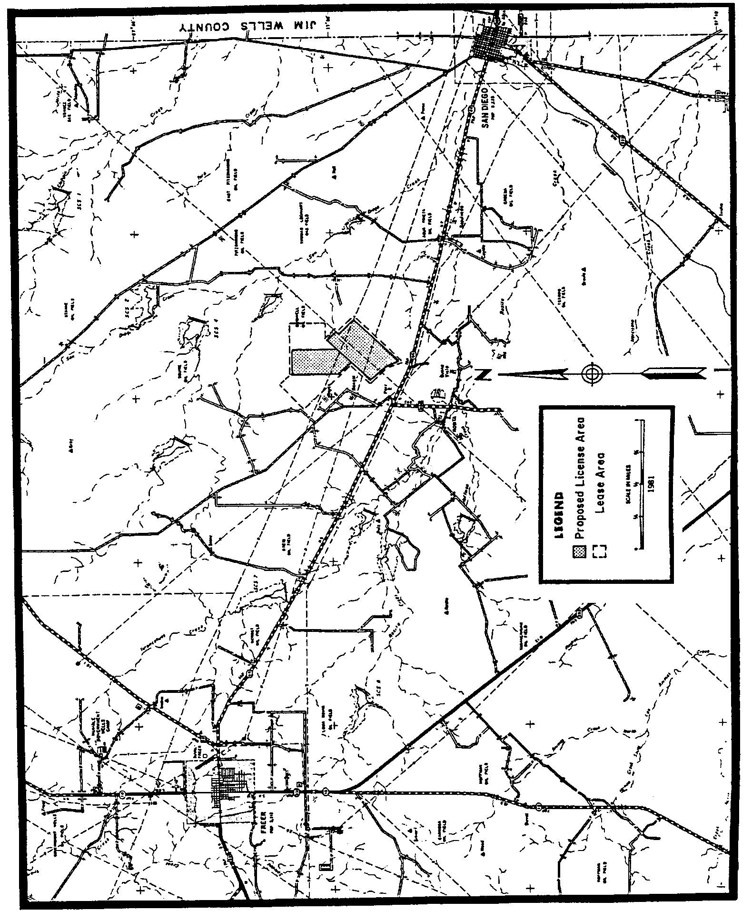

Figure 3: Sample Mine Area Map
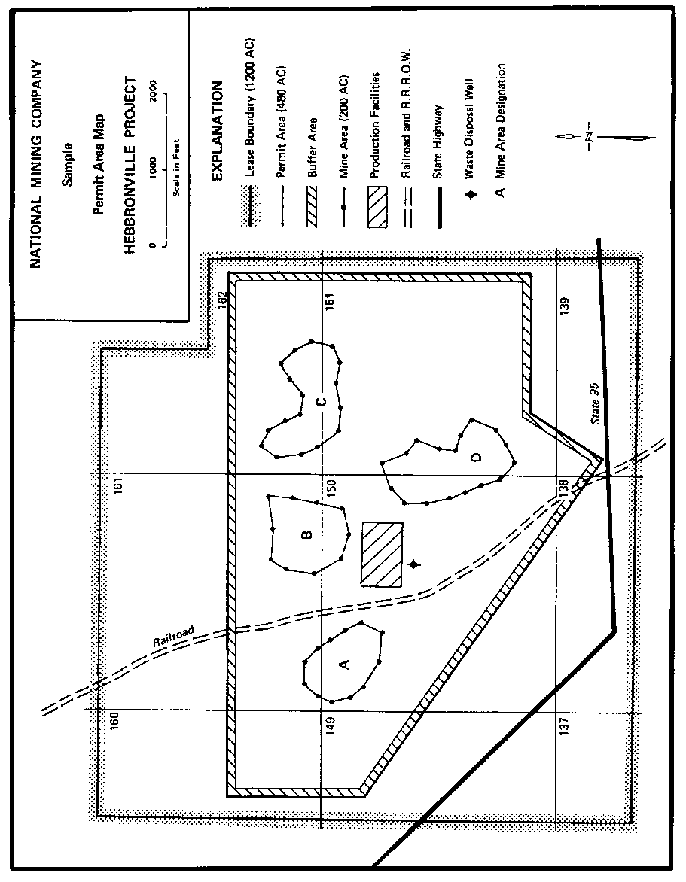

Figure 4: Sample Proposed Production Area Map
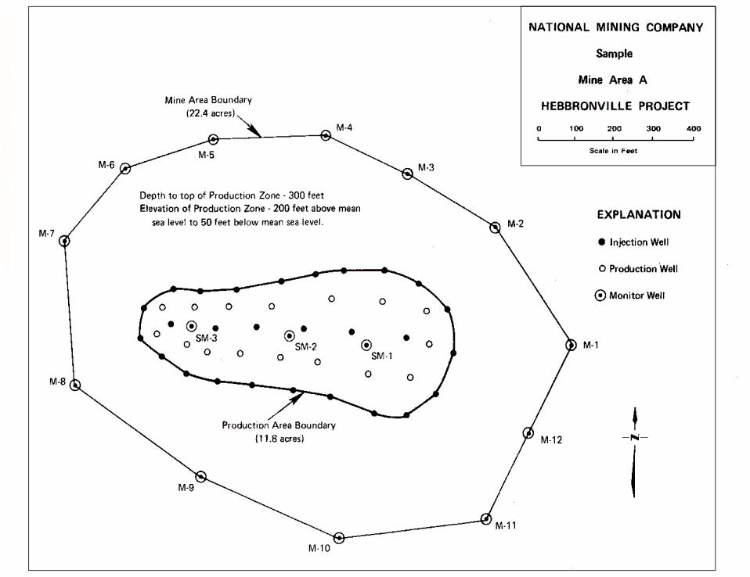

Table 1 - Groundwater Quality Data Report for Production and Mine Area Wells
Well Owner:
Well Number:
Well Location:
Date of Sample:
Date of Water Sample Analysis:
Name of Laboratory Performing Analysis:
Parameter | Unit | Analyzed Value
Calcium | mg/l
Magnesium | mg/l
Sodium | mg/l
Potassium | mg/l
Carbonate | mg/l
Bicarbonate | mg/l
Sulfate | mg/l
Chloride | mg/l
Fluoride | mg/l
Nitrate - N | mg/l
Silica | mg/l
pH | std. units
TDS | mg/l
Conductivity | μmhos
Alkalinity | mg/l as CaO3
Ammonia | mg/l
Arsenic | mg/l
Cadmium | mg/l
Iron | mg/l
Lead | mg/l
Manganese | mg/l
Mercury | mg/l
Molybdenum | mg/l
Selenium | mg/l
Uranium | mg/l
Radium | pCi/l
Groundwater Quality Data Report for Production and Mine Area Wells:
Company:
Mine:
Permit: Prod. Area:
Date Summarized:

Table 2 – Part A Non Production Zone Baseline Values
Parameter | Unit | Low | Average | High | Well I.D. By Area*
Calcium | mg/l
Magnesium | mg/l
Sodium | mg/l
Potassium | mg/l
Carbonate | mg/l
Bicarbonate | mg/l
Sulfate | mg/l
Chloride | mg/l
Fluoride | mg/l
Nitrate - N | mg/l
Silica | mg/l
pH | std. units
TDS | mg/l
Conductivity | μmhos
Alkalinity | mg/l as CaO3
Ammonia | mg/l
Arsenic | mg/l
Cadmium | mg/l
Iron | mg/l
Lead | mg/l
Manganese | mg/l
Mercury | mg/l
Molybdenum | mg/l
Selenium | mg/l
Uranium | mg/l
Radium | pCi/l
*List the identification numbers of monitoring wells used to obtain the high and low values for each parameter.
Groundwater Quality Data Report for Production and Mine Area Wells:
Company:
Mine:
Permit: Prod. Area:
Date Summarized:

Table 2 – Part B Production Zone Baseline Values
Parameter | Unit | Mine Area Low | Mine Area Average | Mine Area High | Production Area Low | Production Area Average | Production Area High | Well I.D. in Mine Area* | Well I.D. in Production Area*
Calcium | mg/l
Magnesium | mg/l
Sodium | mg/l
Potassium | mg/l
Carbonate | mg/l
Bicarbonate | mg/l
Sulfate | mg/l
Chloride | mg/l
Fluoride | mg/l
Nitrate - N | mg/l
Silica | mg/l
pH | std. units
TDS | mg/l
Conductivity | μmhos
Alkalinity | mg/l as CaO3
Ammonia | mg/l
Arsenic | mg/l
Cadmium | mg/l
Iron | mg/l
Lead | mg/l
Manganese | mg/l
Mercury | mg/l
Molybdenum | mg/l
Selenium | mg/l
Uranium | mg/l
Radium | pCi/l
*List the identification numbers of monitoring wells used to obtain the high and low values for each parameter.

http://www.tbpe.texas.gov/
http://www.tbpg.state.tx.us/
http://www.tceq.texas.gov/permitting/waste_permits/uic_permits/UIC_Guidance_Class_3.html
http://www.tceq.texas.gov/permitting/central_registry/guidance.html
http://www.tceq.texas.gov/assets/public/compliance/compliance_support/qa/txnelap_lab_list.pdf
http://www.tceq.texas.gov/permitting/waste_permits/ihw_permits/qapp.html
www.tceq.texas.gov/assets/public/permitting/waste/uic/tech_guideline_2.pdf
www.tceq.texas.gov/permitting/waste_permits/uic_permits/UIC_Guidance_Class_3.html
www.tceq.texas.gov/assets/public/compliance/compliance_support/qa/txnelap_lab_list.pdf
http://www.tceq.texas.gov/permitting/waste_permits/ihw_permits/qapp.html

