Texas Commission on Environmental Quality
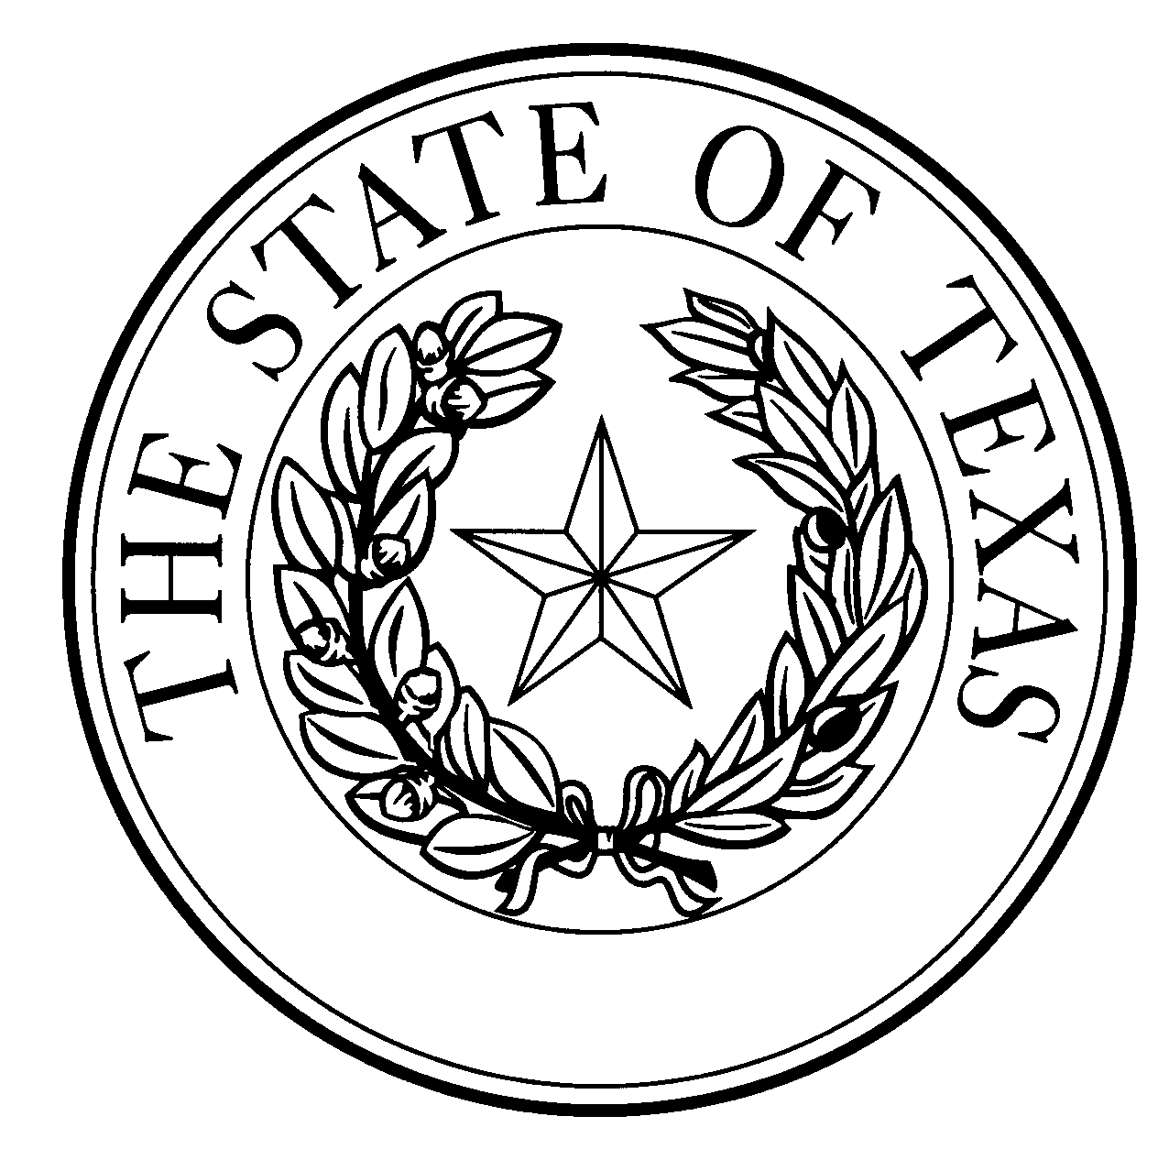
  - Notice of Concentrated Animal Feeding Operation Application
General Permit Authorization No. TXG921196
Application. Prestage Farms of Oklahoma, LLC, P.O. Box 509, Texhoma, Oklahoma, 73949 has applied to the Texas Commission on Environmental Quality (TCEQ) under General Permit No. TXG920000 for a non-substantial change to the terms of the nutrient management plan (NMP) previously submitted to the TCEQ. The Applicant is proposing to change the site name from “Murphy Farms Finishers 15 – 18” to “Farms 15 – 18”; and add covered anaerobic digesters to existing Retention Control Structures (RCSs) #15 and #18 for the recovery of gas for beneficial use. Once the digestion is completed, the wastewater will be returned to the RCS at each farm (RCSs 16 and 17). The design calculations were revised to decrease the storage days from 60 to 30, which changed the required capacity for RCS #16 from 41.50 to 12.37 acre-feet, and RCS #17 from 41.93 to 12.36 acre-feet. The required capacity for RCS 15 is 7.35 acre-feet and for RCS 18 is 7.51 acre-feet. The authorized maximum capacity of 29,500 total swine weighing 55 lbs or more, and 712 acres of land application area will not change. The NMP for this facility is a no planned land application, and the alternative method for disposal of wastewater is by evaporation. The notice of change application and the updated NMP were received by TCEQ on September 7, 2022.
No discharge of pollutants into the waters in the state is authorized by this general permit except under chronic or catastrophic rainfall conditions or events. All waste and wastewater will be beneficially used on agricultural land.
The facility is located approximately 10.1 miles south of the intersection of U.S. Highway 54 and Farm-to-Market road 119 at the southeast side of the intersection of Farm-to-Market road 119 and State Highway 15 in Texhoma, Sherman County, Texas. The facility is located in the drainage area of unclassified Segment No. 0100 of the Canadian River Basin. The following link to an electronic map of the site or facility’s general location is provided as a public courtesy and is not part of the application or notice. https://gisweb.tceq.texas.gov/LocationMapper/?marker=-101.8058,36.2597&level=18. For the exact location, refer to the application.
The Executive Director of the TCEQ has approved the proposed non-substantial change to the terms of the NMP. The revised terms of the NMP have been included in the permit record and it is available at the TCEQ’s Central Records, 12100 Park 35 Circle Austin, Texas 78753.
Information. For additional information about this application, contact Kayla Robichaux at (512) 239-4742. Si desea información en Español, puede llamar al 1-800-687-4040. General information regarding the TCEQ can be found at our web site at www.tceq.texas.gov/.

Issued: December 7, 2022

