**Tips on How to Use Search Filters and Export Data**

* Click the drop-down arrow next to “Select…” on the filter you want to use. Once you input your selection, be sure to click the “Apply” button. Note: Clear all filters before starting a new search.



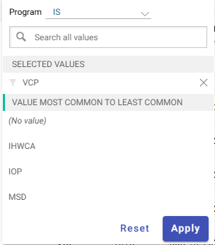

* Click on this box (An image of the 'Colomns' icon.) to uncheck any columns you want to hide.

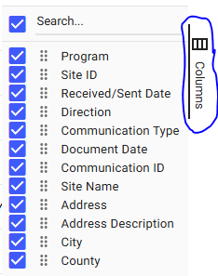

* Click on the ellipse (An image of an ellipsy.) to export and download the data.

A screenshot with a circle around the ellipsy.