Data Used in the Update
In December 2021, the Data Subcommittee gathered and reviewed existing available data that may indicate progress or otherwise inform the selection of management measure and control actions. Members of the Data Subcommittee included Austin Water (COA), Watershed Protection Department (COA), University of Texas, and TxDOT. Data for consideration included that which was current available at that time in TCEQ SWQMIS, in City of Austin database, collected the University of Texas, and by the Colorado River Watch Network (CRWN).

Data evaluated in TCEQ SWQMIS
Data in SWQMIS is the only data that can be included in calculations to determine compliance because it is collected/submitted by entities under an approved TCEQ QAPP. E.coli concentrations submitted in SWQMIS are accompanied by instantaneous discharge (flow) measurements and TCEQ flow severity codes. All E.coli samples in SWQMIS were collected pursuant to the applicable SWQM manual and analyzed in a NELAP-accredited laboratory using the IDEXX method.
Sample concentrations evaluated during the development of 2015-2020 I-Plan, as well as samples collected during the 2015-2020 I-Plan implementation are presented in Figures DS1-DS6. Most samples are analyzed with a maximum value of 2419 MPN due to analysis limitations; however, some samples were analyzed as dilutions to enable greater resolution, therefore some values are greater than 2419 may. It should be noted that concentrations shown in the graphs of 2419 MPN may in fact be greater. In addition to being the only site with concentrations that included dilutions (and therefore some concentrations exceeding 2419 MPN) Station 16331 (Waller Creek at Avenue H) was the only Assessment Unit in which the linear average trend line did not show a decrease in E.coli concentration.

FIGURE DS1. SWQMIS data before and during the 2015-2020 I-Plan for Assessment Unit 1429C_03

FIGURE DS2. SWQMIS data before and during the 2015-2020 I-Plan for Assessment Unit 1429C_02

FIGURE DS3. SWQMIS data before and during the 2015-2020 I-Plan for Assessment Unit 1429C_01

FIGURE DS4. SWQMIS data before and during the 2015-2020 I-Plan for Assessment Unit 1428B_05

FIGURE DS5. SWQMIS data before and during the 2015-2020 I-Plan for Assessment Unit 1403K_01

FIGURE DS6. SWQMIS data before and during the 2015-2020 I-Plan for Assessment Unit 1403J_01

Data evaluated from City of Austin
The City of Austin database includes the data that has been submitted in SWQMIS in addition to samples that were collected prior to the QAPP, samples that were collected for other projects (not under the QAPP), and/or samples that were processed at COA WPD laboratory but not submitted due to lack of NELAP accreditation. Some of this data fills in the gaps from Dec 2010 - Dec 2014 in Figures DS1-6, however, this data will not be used in the assessment for geomeans if it was not collected under an approved QAPP. However, this “extra” data (Table DS1) was reviewed by the Data Committee during the I-Plan review.
Table DS1. City of Austin data available to the public, but not included in SWQMIS for the period of Dec 2010-Dec 2014
TCEQ STATION | COA Site ID | Date | E.Coli MPN
17294 Taylor Slough Pecos | 318 Taylor Slough @ Reed | 10/6/2010 | >2419.6
17294 Taylor Slough Pecos | 318 Taylor Slough @ Reed | 12/8/2011 | 133.3
17294 Taylor Slough Pecos | 318 Taylor Slough @ Reed | 3/7/2012 | 365.4
17294 Taylor Slough Pecos | 318 Taylor Slough @ Reed | 7/5/2012 | 517.2
17294 Taylor Slough Pecos | 318 Taylor Slough @ Reed | 9/12/2012 | 387.3
17294 Taylor Slough Pecos | 318 Taylor Slough @ Reed | 1/15/2014 | 313
17294 Taylor Slough Pecos | 318 Taylor Slough @ Reed | 4/17/2014 | 235.9
17294 Taylor Slough Pecos | 318 Taylor Slough @ Reed | 7/2/2014 | 1203.3
12235 Waller at 2nd St | 38 Waller @ Cesar Chavez | 12/1/2010 | 686.7
12235 Waller at 2nd St | 38 Waller @ Cesar Chavez | 3/23/2011 | 222.4
12235 Waller at 2nd St | 38 Waller @ Cesar Chavez | 6/7/2011 | 387.4
12235 Waller at 2nd St | 38 Waller @ Cesar Chavez | 9/21/2011 | 158.5
12235 Waller at 2nd St | 38 Waller @ Cesar Chavez | 1/22/2013 | 261.3
12235 Waller at 2nd St | 38 Waller @ Cesar Chavez | 4/24/2013 | 517.2
12235 Waller at 2nd St | 38 Waller @ Cesar Chavez | 6/26/2013 | 1203.3
15962 Waller at 24th St | 624 Waller at 23rd Street | 12/1/2010 | 727
15962 Waller at 24th St | 624 Waller at 23rd Street | 3/23/2011 | 290.9
15962 Waller at 24th St | 624 Waller at 23rd Street | 6/7/2011 | 547.5
15962 Waller at 24th St | 624 Waller at 23rd Street | 9/21/2011 | 365.4
15962 Waller at 24th St | 624 Waller at 23rd Street | 1/22/2013 | >2419.6
15962 Waller at 24th St | 624 Waller at 23rd Street | 4/24/2013 | 920.8
15962 Waller at 24th St | 624 Waller at 23rd Street | 6/26/2013 | 1119.9
15962 Waller at 24th St | 624 Waller at 23rd Street | 9/26/2013 | 1553.1

In addition to data that partially informs the gap prior to the 2015 five-year I-Plan implementation, the City of Austin data base includes samples following the five-year implementation. As of the time of this report,
Table DS2. City of Austin data 2019-2022 following the five-year I-Plan implementation
TCEQ STATION | COA Site ID | Date | E.Coli MPN
17294 Taylor Slough Pecos | 318 Taylor Slough @ Reed
12235 Waller at 2nd St | 38 Waller @ Cesar Chavez
15962 Waller at 24th St | 624 Waller at 23rd Street
16316 Spicewood Trib to Shoal | 930 Spicewood Trib d/s
17251 Walnut d/s Loop 1 | 497 Walnut Creek @MoPac
16331 Waller at Avenue H | 781 Waller Creek at Shipe

Data evaluated from the University of Texas
Data provided by the University of Texas included quarterly data from 2/18/2020 to 7/16/2021 at three sites on Waller Creek within campus boundaries which would be in near TCEQ Station 15962 within the Assessment Unit 1429C_02 (Figure DS7). Although this is a relatively small time frame, the trendlines for all three sites over the study period indicated decreasing concentration.
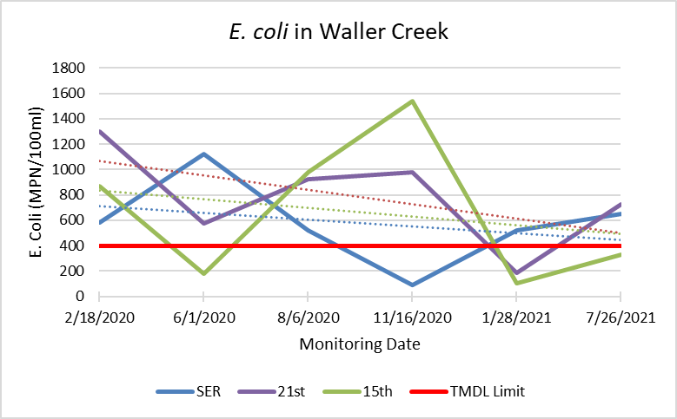
FIGURE DS7. Recent samples on collected by the University of Texas on campus indicate an apparent trend of reducing E.coli concentrations at three locations within the Assessment Unit 1429C_02 to include: Waller Creek at SER (near the Service Building upstream of 24th St), 21st (mid-campus near the stadium), and 15th Street.

Data evaluated from the Colorado River Watch Network
Data available through the CRWN was not included in the I-Plan update. The reasons cited by the data committee included: the method of sample processing was not IDEXX and therefore less comparable to other data, antecedent weather conditions for sample events were unclear, QA/QC methods were not verifiable, and only two applicable sites were available.

Summary of Data Used
Based on the available data evaluated at the time of Data Subcommittee review, it was determined that no additional data was necessary on which to base progress or otherwise inform the selection of management measure and control actions. Stakeholders were encouraged that the majority of trends indicate improvement (decreasing concentration over time). In fact, only one Assessment Unit (Waller Creek at Avenue H) had a trend that was of increasing concentration, however the trend was virtually flat and likely indicates “no change” rather than an increase. It is not determined during the review that the facets of the I-Plan were responsible for the improvements in most assessment units, however, the trends to imply that staying the course may result in compliance in the near future.

