Public Water System Plant Operations Manual

# Public Water System Information

Table 1 - Public Water System Information

|  |  |
| --- | --- |
| **Public Water System ID:** |  |
| **Public Water System Name:** |  |
| **Effective Date:** |  |

## ****Water System Primary Source Type****

Groundwater

Purchased Water

Surface Water

## ****Water System Type****

Community

Nontransient, Noncommunity (NTNC)

Transient Noncommunity (TNC)

# Introduction

## Purpose of a Plant Operations Manual

In accordance with [30 Texas Administrative Code (TAC) 290.42(l)](https://texas-sos.appianportalsgov.com/rules-and-meetings?$locale=en_US&interface=VIEW_TAC_SUMMARY&queryAsDate=05%5C28%5C2025&recordId=215895), a thorough plant operations manual must be completed and kept up-to-date for operator review and reference. The intent of the plant operations manual is to provide enough detail for the operator to perform routine maintenance and repair procedures. The manual should include the protocols to be implemented in the event of a catastrophe or a temporary or permanent loss of key personnel. This manual should also contain contact information for all water system personnel, local, state/federal agencies to be contacted in emergencies.

## General Instructions

At a minimum, this manual must include the information to ensure the continuity of operations. Update your manual as necessary, including when significant changes are made, after an emergency event that impacts your operations, or at least every three years. **Examples are provided in** italics **and should be replaced with information specific to your system. Keep your plant operations manual permanently.**

1. https://texas-sos.appianportalsgov.com/rules-and-meetings?$locale=en_US&interface=VIEW_TAC_SUMMARY&queryAsDate=05%5C28%5C2025&recordId=215895

# Points of Contact Information

## Water System Contacts

Table 2 - Water System Contacts

|  |  |  |  |
| --- | --- | --- | --- |
| **Title** | **Name** | **Phone Number** | **Email** |
| *Administrative Assistant* |  |  |  |
| *Owner/Legal Contact* |  |  |  |
| *Chief Operator* |  |  |  |
| *Operator* |  |  |  |
| *Backflow Prevention Assembly Tester* |  |  |  |
| *Customer Service Inspector* |  |  |  |

## Emergency Contacts

*Below are examples of emergency personnel that are essential to the water system. Add or delete contacts as needed.*

Table 3 - Emergency Contacts

| **Company/Title** | **Name** | **Phone Number** | **Email** |
| --- | --- | --- | --- |
| *Electrical Company* |  |  |  |
| *Pump Repairs* |  |  |  |
| *Line Repairs* |  |  |  |
| *County Sherriff* |  |  |  |
| *Chief of Police* |  |  |  |
| *County/City Official* |  |  |  |
| *Fire Department* |  |  |  |
| *Chemical Vendor* |  |  |  |
| *Instrumentation Technician* |  |  |  |
| *NELAP-Accredited Laboratory* |  |  |  |
| *TCEQ Regional Office* |  |  |  |

## Water Sources

### Ground Water Sources

Table 4 - Ground Water Sources

|  |  |  |  |  |  |  |
| --- | --- | --- | --- | --- | --- | --- |
| **Well Name** | **TCEQ Well ID** | **Aquifer Name** | **Well Depth** | **Well Location** | **Drill Date** | **Well Pumping Capacity** |
| *North well* | *G1234567A* | *Edwards-Trinity Aquifer* | *300 feet (ft)* | *123 North Dr.* | *1996* | *90 gallons per minute (GPM)* |
|  |  |  |  |  |  |  |

## *Surface Water Sources*

Table 5 - Surface Water Sources

|  |  |  |  |  |  |  |
| --- | --- | --- | --- | --- | --- | --- |
| **Intake Name** | **TCEQ Intake ID** | **Surface Water Source Name** | **Intake Location** | **Intake Type** | **Operating Depth** | **Pumping Capacity** |
| *Intake #1* | *S1234567A* | *Blue Lake* | *123 South Shore Dr., Blue Lake, TX* | *Fixed* | *10 ft* | *Pump #1-90 GPM*  *Pump #2-90 GPM* |
|  |  |  |  |  |  |  |

## *Purchased Water Sources*

Table 6 - Purchased Water Sources

|  |  |  |  |  |
| --- | --- | --- | --- | --- |
| **Wholesaler Name and TCEQ PWS ID** | **Source** | **Meter Location** | **Maximum Purchase Rate** | **Direct Pressure or through a plant?** |
| *Wholesaler: Bob’s WSC*  *PWS ID: TX9876543* | *Edwards Aquifer* | *123 Elm Dr.,*  *Here, TX* | *2.0 million gallons (MG) per month at 60 pounds per square inch (psi)* | *Direct pressure to pressure plane 1* |
|  |  |  |  |  |

**\*If purchased water system, include a copy of the purchase water contract\***

# Treatment Plants

Describe the overall treatment process (all equipment included), capacity of each treatment component, type of chemicals used, how they are injected, and what residual goal you attempted to achieve. List any emergency interconnections or backup water sources if available and the total number of connections and population served. Maintain engineering plans and specifications for all components.

*Example: The plant design includes: 1 well (rated 24 GPM) that pumps into 1 ground storage tank (3,300 gallons), then suction by two 2-hp centrifugal service pumps rated at 40 GPM each that pump into the distribution system under a hydropneumatic pressure tank (220 gallons). All of this can be controlled by a pressure switch located above the control panel.*

*This plant utilizes chlorination (a sodium hypochlorite blend). Liquid chlorine is added with a chlorine regulator and water injector at the treatment plant. The rotameter setting is typically 0.6 gallons per day (GPD). A free chlorine residual is to be maintained between 1 and 1.5 mg/L at the plant, to allow for required residuals in the distribution lines. This system has no emergency interconnections or backup water sources. The system actively serves 18 connections and 32 people.*

## Critical Plant Equipment

Describe the details of all plant equipment, including critical components and a description of how the equipment functions. Find examples of common critical components in Appendix A. Modify this section according to the equipment at your system.

### WELL

*Example: The float switch in the ground storage tank controls the well. The well comes on automatically when the level in the ground storage tank drops below a pre-determined level. The well can also be turned on manually at the tank. The manual switch is needed to check the well during routine inspections. If the well does not operate with the manual switch on, the operator should inspect the breaker, telephone relay connections, and/or starter resets at the well. If the well still does not operate, call an electrician to test the pump motors.*

**Critical Components:** *well head, exposed pipes, electrical lines and equipment, well pump, valves, gauges, and meters.*

### GROUND STORAGE TANK

*Example: The ground storage tank is equipped with a float switch, which controls the whole plant depending upon the water level in the ground storage tank. The float turns the well off and on at a pre-determined level.*

**Critical Components:** *exposed inlet/outlet pipes, vents, pressure relief devices, valves, pressure gauges, liquid level indicators and sight glasses, cathodic protection*

### TRANSFER AND SERVICE PUMPS

*Example: The pressure switch at the pressure tank controls the service pumps. They operate automatically depending on the water level in the pressure tanks. The pumps can be manually operated at the control switch. No transfer pumps are provided.*

**Critical Components:** *exposed inlet/outlet pipes, electrical lines and equipment, valves, pressure gauges, meters, pumps and motors.*

### PRESSURE TANK

*Example: The 220-gallon hydropneumatic pressure tank has a pressure relief valve, a pressure gauge, and a drain valve.*

**Critical Components:** *exposed inlet/outlet pipes, valves, pressure gauges, meters, electrical lines and equipment, pumps and motors.*

### ELECTRICAL AND CONTROLS

*Example: The central breaker panel contains a main breaker, which controls all the electricity inside the plant, and several smaller breakers that control the electricity to individual pumps, air compressor, lights, and other electrical outlets. The motor starters are for each individual pump motor and contain motor protection in each. All pumps, motors, and chemical feed pumps can be manually or automatically turned on and off at the main panel. It contains relays, alternator, and manual-**off-auto switches.*

**Critical Components:** *electrical lines, switches, fuses, brakers, surge protectors.*

### CHLORINE FEED EQUIPMENT

*Example: There is a water injector to feed liquid chlorine. Once the water level in the storage tank reaches the top, the controller will stop the well motor and chlorine feed. The only way the chlorine feed can be turned on manually is to turn the well on manually at the control switch. This prevents the chlorine feed from injecting chlorine into the system if the well is not running. A plant flow schematic is attached as an appendix at the end of this document.*

**Critical Components:** *exposed feeder and transfer lines, electrical lines and equipment, pumps and motors, valves, gauges, and meters.*

### AUXILIARY POWER

*Example: There is a portable generator stored in the well house. If the system loses electricity, this generator can be used to power the plant. To start the generator, check that it has adequate fuel and oil. Turn on the fuel valve and ignition switch to the ON position. Press the electric start button.*

**Critical Components:** *electrical lines and equipment, switches, fuses, brakers, fuel lines, cooling and lubricant lines, exhaust systems, batteries and terminals, valves and gauges.*

# Distribution System

Describe the facilities in the distribution system, including the capacity of each component, type of chemicals used and how they are injected (if applicable), and the total number of connections and population served. If the distribution consists of more than one pressure plane, include this information for each plane.

Attach map(s) of the distribution system to this manual. Update and maintain distribution maps so that valves and mains can be easily located. Maintain engineering specifications for all distribution components. Keep these documents in a readily available location.

*Example: The distribution system consists of three pressure planes.*

* *Pressure Plane 1 consists of two booster stations each with one ground storage tank (0.5 million gallon (MG) each) and two vertical turbine service pumps (rated 40 GPM each). One elevated storage tank (0.2 MG) maintains pressure. Pressure Plane 1 serves 50 connections and 150 people.*
* *Pressure Plane 2 consists of one standpipe (0.3 MG and 100-ft in height), one bladder pressure tank (220 gallons), two service pumps (rated at 15 GPM each), and serves 20 connections and 63 people.*
* *Pressure Plane 3 consists of three booster stations, one elevated tank (1.0 MG), and serves 800 connections and 2,589 people. Booster station 1 consists of one ground storage tank (0.25 MG), two centrifugal service pumps (rated 25 GPM each, and two 50-gallon bladder pressure tanks. Booster station 2 consists of two ground storage tanks (0.5 and 0.75 MG), each with two service pumps (rated 50 GPM each). Booster station 3 consists of one ground storage tank (1.0 MG) and four service pumps (rated 100 GPM each).*

*A distribution schematic identifying the areas served by each pressure plane is attached as an appendix at the end of this document.*

**Critical Components:** *exposed water lines (e.g. bridge or water crossings), valves, gauges, and meters (excluding individual/customer meters), pumps and motors, backflow prevention devices, wholesale/purchase water interconnections.*

# Routine Operational, Maintenance, and Repair Procedures

Document the routine operational, maintenance, and repair procedures that occur daily, weekly, monthly, quarterly, and annually at your system. Add additional procedures as necessary. Blank inspection logs to record this information can be found in the [Public Water System Compliance Notebooks](https://www.tceq.texas.gov/assistance/water/pdws/pws.html).[1]

### DAILY

* If you serve **at least 750 people or** **250 connections**, record this information daily:
  + Well/purchased water production at the meter and chemical usage.
  + Chlorine residual measured at representative sites in the distribution system. Sample sites should be identified in your monitoring plan.

### WEEKLY

* If you serve **fewer than 750 people or 250 connections**, record the following information weekly:
  + Well/purchased water production at the meter and chemical usage.
  + Chlorine residual measured at representative sites in the distribution system. Sample sites should be identified in your Monitoring Plan.
* Check the amount of chlorine remaining that can be fed into the system. Replace, if needed.
* Maintain the grounds, equipment, and facilities in good working condition. Keep well houses and other facilities free of tall grass. Check that all gates and fences are secured. Document all maintenance and repairs in a log.

### MONTHLY

#### Routine Bacteriological Sampling

* Collect at least the minimum number of routine bacteriological samples from the distribution system. Sample locations and sampling protocols must be identified in your Monitoring Plan and Revised Total Coliform Rule Sample Siting Plan. Send samples to a National Environmental Laboratory Accreditation Program (NELAP)-accredited laboratory for analysis.

#### Prepare Monthly Operating Report

* Prepare the monthly operation report from the daily or weekly log sheets and file accordingly. This report should summarize the following each month: the amount of water distributed, the amount of chemicals used to treat the water, and records of the disinfectant residuals collected from the distribution system.

#### Flush Dead-End Mains

* Flush all dead-end mains in the distribution system monthly. Flush dead-end lines and other mains as needed. Record details of all flushing events.

#### Inspect Emergency Generators

* Inspect and test emergency generators monthly. Perform maintenance, if needed, and record findings.

#### Inspect Water and Chemical Pumps

* Check chlorine feed pump and injector, well, flow meter, pumps, pressure tanks, storage tanks and ensure all are operating properly. Add oil or lubricants if needed. Document maintenance performed.

### QUARTERLY

#### Prepare Disinfectant Level Quarterly Operating Report

* Prepare summaries of your disinfectant levels and submit the Disinfectant Level Quarterly Operating Report (DLQOR) to TCEQ each quarter.

#### Check Accuracy of Disinfectant Analyzers

* Check that your manual disinfectant residual analyzers are properly calibrated. Manual analyzers must be checked at least once every 90 days. Continuous analyzers must be checked at least once every 7 days. Record all verification checks in a log.

### YEARLY

#### Inspect Water Storage and Pressure Tanks

* Complete annual tank inspections for ground, elevated, and pressure tanks. Inspections may be performed by water system personnel or a contacted inspection service. Interior inspections of pressure tanks must be completed at least once every 5 years. Use a separate log sheet for each storage tank and pressure tank.

### EVERY 3 YEARS

* Calibrate or replace well meters/purchased water meters.
* Community water systems should prepare for a Comprehensive Compliance Investigation of the system.

# Water Treatment Chemicals

Keep a log of all chemicals used at your water system. Use the table below to record the type of chemical, vendor contact information, where the injection point is located, frequency at which the chemical is replaced, and the contact information for a backup chemical vendor.

## Inventory of Water Treatment Chemicals

Table 7 - Water Treatment Chemical Inventory

|  |  |  |  |  |
| --- | --- | --- | --- | --- |
| **Chemical Type** | **Vendor Contact Information** | **Injection Point** | **Frequency of Replacement** | **Emergency Backup Vendor** |
| *Gas Chlorine* | *The Chemical Guy 800-888-8888* | *In the pump house between the meter and valve* | *New bottle needed every 8 days* | *The Chemical Co. 800-999-9999* |
| *Polyphosphate* | *The Chemical Guy 800-888-8888* | *In the pump house before the Cl2 injection after the meter* | *Chemical vendor refills every 15 days* | *The Chemical Co. 800-999-9999* |
|  |  |  |  |  |
|  |  |  |  |  |
|  |  |  |  |  |

# Standard Operating Procedures

This manual must include standard operating procedures (SOPs) for routine and emergency conditions at the water system. Examples are given in *italics*. Replace the example language with instructions to represent the actual processes at your system. Add additional SOPs for any processes, treatment, etc. not already listed.

* **Chemical Dosing and Adjustments**
* *Example: Operator should test the chlorine residual at the entry point tap in the pump house daily. The chlorine residual should be between 1.0 and 1.5 milligrams per liter (mg/l) at the entry point. If the chlorine is below 1.0 mg/l, adjust the rotameter so the bottom of the ball moves up by 0.2 mg/l. Test the chlorine residual at the entry point again and re-adjust the chlorine dose, if needed. If the chlorine is above 1.5 mg/l, adjust the rotameter so the bottom of the ball moves down by 0.2 mg/l. Record the start and end (if any adjustments were made) chlorine dosage on the well log sheet in the pump house.*
* **Process Control Sampling**
* *Example: The operator should take a sample at the entry point of each plant daily to make sure the chlorine residual is between 1.5-2.0 mg/l. The chlorine residual should be recorded on the well sheet located in the pump house.*
* *Example (for systems that distribute chloraminated water): The operator must measure total chlorine, monochloramine, and free ammonia at each entry point weekly and nitrite and nitrate at the first customer quarterly. Consult the system’s Nitrification Action Plan for the desired ranges for each parameter.*
* **Calibration and Accuracy Checks of Monitoring Equipment (for online, benchtop, portable monitoring equipment)**
* *Example: A verification of the calibration for the DR900 Colorimeter must be done at least once every 90 days with the secondary gel standards. Start the program 80 Chlorine F&T PP. Clean the blank sample cell and place it into the cell holder. Press the “Zero” button. Remove the blank. Clean the first gel standard and place it into the cell holder. Make sure the arrows line up. Press read and record the values shown on the screen. Continue with the next two gel standards. Compare the results with the list of allowable limits on the “Certificate of Analysis” provided with the standards. If the results are outside of the allowable limits, notify the supervisor.*
* **Emergency Protocols (i.e., for natural or manufactured catastrophes)**
* *Example:* *If the weather is predicted to be below freezing all exposed pipes should be insulated and space heaters turned on in areas where they are needed. All generators must be checked to ensure they are ready to run. Check fuel supply for generators and use anti-gel for diesel engines as needed. Verify that all critical components are prepared for below-freezing temperatures. Verify the system has an adequate supply of water treatment chemicals. Consult the system’s Emergency Preparedness Plan if there is a threat of a power outage.*
* **Operation Protocols (start-up and shutdown for critical units under normal and emergency conditions, for both manual and automated settings)**
* *Example: If for any reason the system has been offline or down, follow these steps to startup the plant:*

1. *Turn all switches on the main control panel to the OFF position.*
2. *Check the main power source from the electrical company.*
3. *Check all the breakers to be properly reset to ON position.*
4. *Check and reset all monitor starter resets.*
5. *At the main control panel, turn the well switch to ON. The well and chemical feed pumps should start at this time.*
6. *At the main control panel turn either of the service pump switches to the ON position. The pump that was turned to the ON position should start as the storage tank level is above the suction line. Starting the pump will cause the water level and pressure to build in the pressure tank. If the tank does not have a high enough water level, then wait until it does, and the service pump will start.*
7. *When the service pump builds enough pressure in the pressure tank it will shut off.*
8. *At this time all switches should be in the ON position on the main control panel, and the plant should be back to complete automatic operation.*
9. *Open flush valves one or two at a time. They should be run until all air is removed from the distribution system, and a free chlorine residual of at least 0.2 mg/L is obtained at the farthest reaches in the distribution system.*

# Appendix A: Critical Plant Equipment

**Table: 30 TAC 290.47(c) -** The following is a non-exhaustive list of critical equipment. There may be other critical equipment, not listed below, that must be protected from adverse weather conditions to ensure the continuity of operation of individual water production, treatment, storage, distribution, or other facilities.

Table 8 - Critical Plant Equipment

| **Category** | **Subcategories** | **Critical Components** |
| --- | --- | --- |
| *Source* | *Wells*  *Intakes*  *Interconnections* | *Well head*  *Exposed pipes*  *Electrical lines and equipment*  *Pumps and motors*  *Valves, gauges, and meters*  *Backflow prevention devices* |
| *Treatment* | *Rapid mixers*  *Flocculators*  *Clarifiers*  *Filters* | *Exposed pipes*  *Electrical lines and equipment*  *Pumps and motors*  *Mechanical drives and equipment*  *Valves, gauges, and meters* |
| *Chemicals* | *Feeders*  *Storage*  *Containment* | *Exposed feeder and transfer lines*  *Motive water lines*  *Backflow prevention devices*  *Pumps and rotameters*  *Electrical lines and equipment*  *Storage level indicators* |
| *Water Storage* | *Ground storage*  *Elevated storage*  *Pressure tanks* | *Exposed inlet and outlet pipes*  *Vents and pressure relief devices*  *Valves, pressure gauges, and meters, including liquid level indicators and sight glasses*  *Cathodic protection* |
| *Distribution* | *Water lines*  *Fire hydrants*  *Flush valves*  *Isolation valves*  *Booster plants*  *Backflow prevention devices*  *Wholesale/purchase water interconnections* | *Exposed water lines (e.g., bridge or water crossings)*  *Valves, gauges, and meters (excluding individual/retail customer meters)*  *Pumps and motors* |
| *Auxiliary Power* | *Generators*  *Right angle drives*  *Switch gears*  *Fuel storage*  *Fuel Containment* | *Electrical lines and equipment*  *Switches, fuses, and breakers*  *Groundhog rods and surge or lightning arrestors*  *Transformers*  *Fuel lines and equipment*  *Cooling and lubricant lines and equipment*  *Exhaust systems*  *Batteries and terminals*  *Valves and gauges*  *Cathodic protection* |
| *Other Critical Components* | *Supervisory Control and Data Acquisition (SCADA)*  *Programable Logic Controller (PLC)*  *Human-Machine Interface (HMI)*  *Variable Frequency Drive (VFD)* | *Electrical lines and equipment*  *Fuses*  *Surge Protectors/arrestors*  *Uninterrupted Power Supply (UPS)* |

# Appendix B: Example of Groundwater Plant Flow Diagram

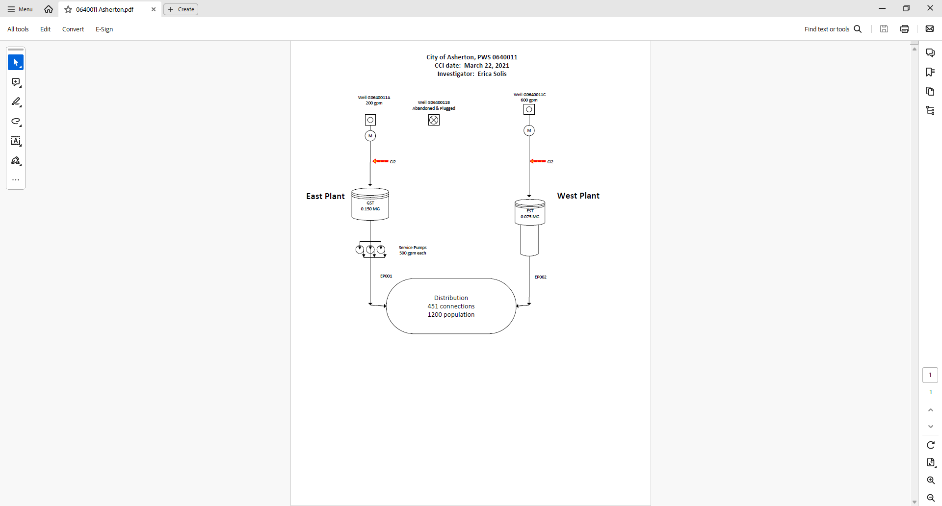

# Appendix C: Example of a Distribution Schematic with Multiple Pressure Planes

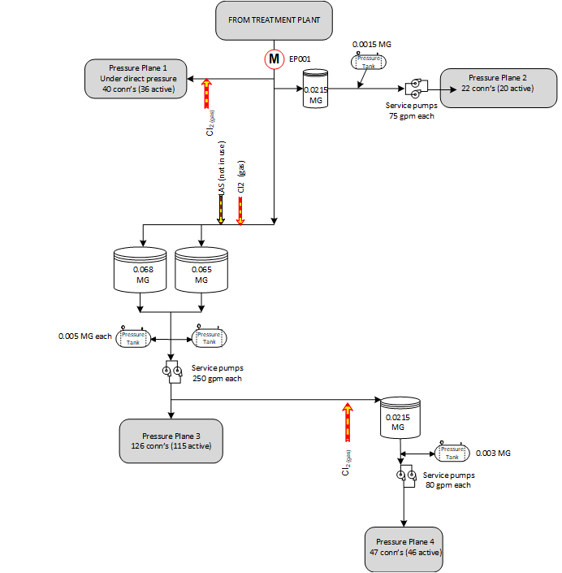

1. 2. www.tceq.texas.gov/assistance/water/pdws/pws.html